A

Project Report

On

“VILLAGE VYAPAR”



Internal Guide: Developed By:

Prof. Hiren Joshi Zeel Chauhan

Devansh Parmar

Parth Lashkari

Himani Raja

**Index**

|  |  |  |
| --- | --- | --- |
| Sr.No | Contents | Page No |
| 1. | Existing System |  |
| 2. | Need for the New System |  |
| 3 | Objective of the New System |  |
| 4 | Project Profile |  |
| 5. | Core Components |  |
| 7 | Assumptions and Constraints |  |
| 8 | Advantages and Limitations of the Proposed System. |  |
| 9. | Requirement Determination |  |
| 10. | Targeted Users |  |
| 11. | Use Case Diagram |  |
| 12. | Class Diagram |  |
| 13. | Interaction Diagram |  |
| 14. | Activity Diagram |  |
| 15. | Data Dictionary |  |
| 16. | Coding Standards |  |
| 17. | Screen Shots |  |
| 18. | Reports |  |
| 19. | Bibliography |  |

**Existing System**

* Existing system is trading between people through calls, and middle man therefore it is limited geographically.

**Need for the New System**

* The geographical limitation stops the business from growing and hence a lot of products do not get much attention.
* It is difficult to account for the sales.
* Cost of product is increased as middle man is included also

there is thin profit margin.

**Objective of the New System**

* This system allows to directly communicate via chat board so customer and seller can negotiate on suitable price.
* To increase the sales of the current small scale village businesses.
* To provide multiple source of the same products which ensures that the customer gets the desired quality product.
* Cost of product is reduced as middle man is eliminated.
* Customer can view products in any native language.

**Project Profile**

* This project is aimed at developing a web application that depicts online shopping of village products such as food, Animals feed, Handicraft etc.
* This web application also allows customer to sell the product and others can purchase or vice versa (i.e. Customer to Customer).
* It provides a communication medium via chat board

**Core Components**

**Admin** :

* Login
* Manage Profile
* Manage Customers
* Manage Category & Sub category
* Manage Products
* Manage Inquiry
* Manage Feedback
* Generate Reports

**Customer :**

* Login
* Manage Profile
* Search Rural Product
* View Categories & Sub Categories
* View Rural Product in multiple language
* Chat with Seller/Buyer
* Inquiry
* Feedback
* Manage Inquiry
* Manage Product
* Manage Wishlist

**Visitor :**

* Registration
* Search Rural Product
* View Rural Product
* View Feedback & Rating

**Requirement Determination**

**Software Requirement:**

Operating System:

* Windows 10

Front end:

* PHP 7.42
* Bootstrap
* Javascript

Back end:

* MySQL

Server:

* Apache/2.4.48

Package:

* Xampp 7.4.22

Diagram Builder:

* Visual paradigm(community) 16.3
* Mysql workbench 8.0

Presentation builder:

* Microsoft powerpoint 16

**Hardware Requirement** :

* **Processor :** Intel core i3

* **RAM :** 8GB
* **Hard disk :** 1TB
* **System type :** 64 bits

**Use Case Diagram**

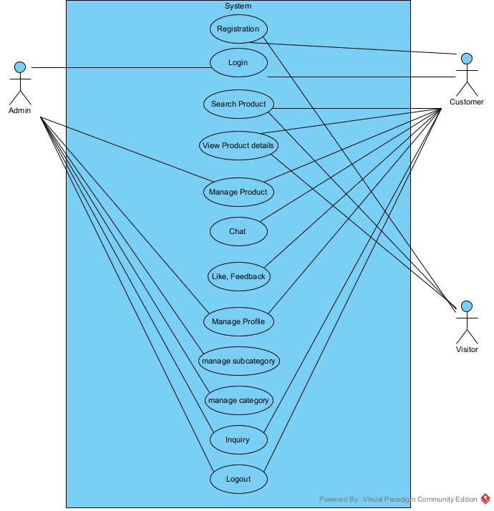

**Class Diagram**

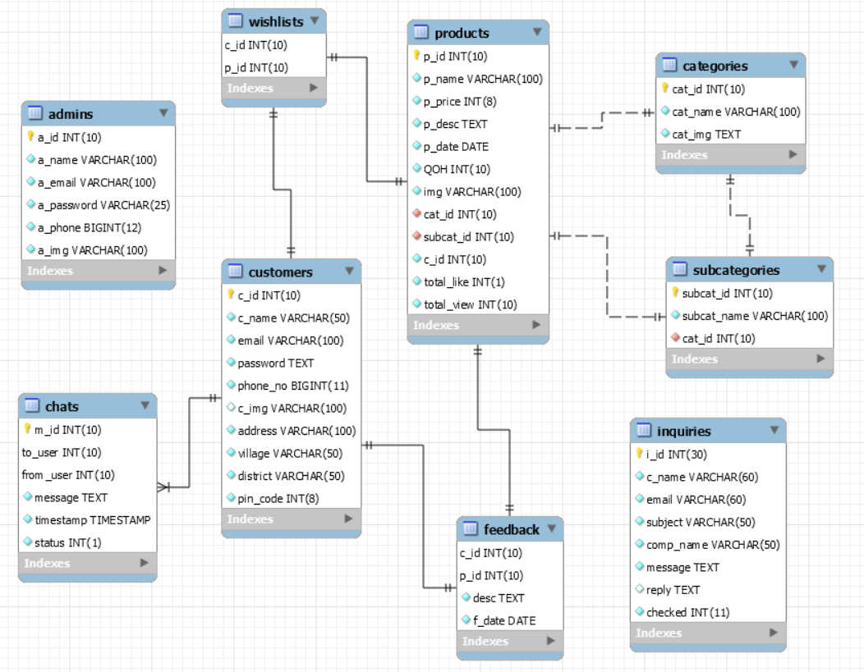

**Interaction Diagram**

**Activity Diagram**

**Data Dictionary**

**1. Admin Table**

**DESCRIPTION :**

* Details of Admin Data table.
* Here a_id is primary key.

|  |  |  |
| --- | --- | --- |
| **Admin** | | |
| Column Name | Type | Constraint |
| a_id | int(10) | Primary key(AI) |
| a_name | varchar(100) | Notnull |
| a_email | varchar(100) | Notnull |
| a_password | varchar(100) | Notnull |
| a_phone | bigint(12) | Notnull |
| a_img | varchar(100) | Default(default.jpg) |

**2. Category Table**

**DESCRIPTION :**

* Details of Category table.
* Here cat_id is primary key.

|  |  |  |
| --- | --- | --- |
| **Categories** | | |
| Column Name | Type | Constraint |
| cat_id | int(10) | Primary key(AI) |
| cat_name | varchar(100) | Notnull |
| cat_img | Text | Notnull |

**3. Chat Table**

**DESCRIPTION :**

* Details of Category table.
* Here cat_id is primary key.
* Here to_user is foreign key.
* Here from_user is foreign key.

|  |  |  |
| --- | --- | --- |
| **Categories** | | |
| Column Name | Type | Constraint |
| m_id | Int(10) | Primary Key(AI) |
| to_user | Int(10) | Foreign Key  (Customer->c_id) |
| from_user | Int(10) | Foreign Key  (Customer->c_id) |
| message | Text | Notnull |
| timestamp | Timstamp | Notnull |
| status | Int(1) | notnull |

**4. Customer Table**

**DESCRIPTION :**

* Details of Customer table.
* Here c_id is primary key.

|  |  |  |
| --- | --- | --- |
| **Customer** | | |
| Column Name | Type | Constraint |
| c_id | Int(10) | Primary Key(AI) |
| c_name | Varchar(50) | notnull |
| email | Varchar(100) | notnull |
| password | Text | Notnull |
| Phone no | bigint | Notnull |
| c_img | varchar(100) | notnull |
| address | Varchar(100) | notnull |
| village | Varchar(50) | notnull |
| district | Varchar(50) | Notnull |
| pincode | Int(6) | notnull |

**5. Feedback Table**

**DESCRIPTION :**

* Details of Feedback table.
* Here c_id is primary key.
* Here p_id is foreign key.

|  |  |  |
| --- | --- | --- |
| **Feedback** | | |
| Column Name | Type | Constraint |
| C_id | Int(10) | Primary Key(AI) |
| P_id | Int(10) | Foreign Key  (product->p_id) |
| Desc | text | notnull |
| f_date | date | Notnull |

**6. Inquiry Table**

**DESCRIPTION :**

* Details of Inquiry table.
* Here cat_id is primary key.

|  |  |  |
| --- | --- | --- |
| **Inquiry** | | |
| Column Name | Type | Constraint |
| i_id | Int(10) | Primary Key(AI) |
| c_name | varchar(50) | notnull |
| Email | Varchar(50) | Notnull |
| Subject | Varchar(50) | Notnull |
| Comp_name | Varchar(50) | Notnull |
| Message | Text | Notnull |
| Reply | Text | Notnull |
| Checked | Int(11) | notnull |

**7. Product Table**

**DESCRIPTION :**

* Details of Product table.
* Here p_id is primary key.
* Here cat_id is foreign key.
* Here subcat_id is foreign key.
* Here c_id is foreign key.

|  |  |  |
| --- | --- | --- |
| **Product** | | |
| Column Name | Type | Constraint |
| p_id | Int(10) | Primary Key(AI) |
| p_name | varchar(100) | notnull |
| p_price | Int(8) | Notnull |
| p_desc | Text | Notnull |
| p_date | Date | Notnull |
| qoh | Int(10) | Notnull |
| img | Varchar(100) | Notnull |
| Cat_id | Int(10) | Foreign key (AI)  Category->c_id |
| Subcat_id | Int(10) | Foreign key(AI)  Subcategory->  subcat_id |
| C_id | Int(10_ | Foreign Key(AI)  Customer->c_id |
| Total_like | Int(1) | Notnull |
| Total_view | Int(10) | Notnull |

**8. Sub-Category Table**

**DESCRIPTION :**

* Details of subcategory table.
* Here subcat_id is primary key.
* Here cat_id is foreign key.

|  |  |  |
| --- | --- | --- |
| **Subcategory** | | |
| Column Name | Type | Constraint |
| Subcat_id | Int(10) | Primary Key(AI) |
| Subcat_name | varchar(100) | notnull |
| Cat_id | Int(8) | Foreign key(AI)  Category->cat_id |

**9. Wish-list Table**

**DESCRIPTION :**

* Details of wishlist table.
* Here c_id is foreign key.
* Here p_id is foreign key.

|  |  |  |
| --- | --- | --- |
| **Wish-list** | | |
| Column Name | Type | Constraint |
| c_id | Int(10) | Foreign key (AI)  Customer->c_id |
| p_id | Int(10) | Foreign key(AI)  product->p_id |

**Screen Shot**

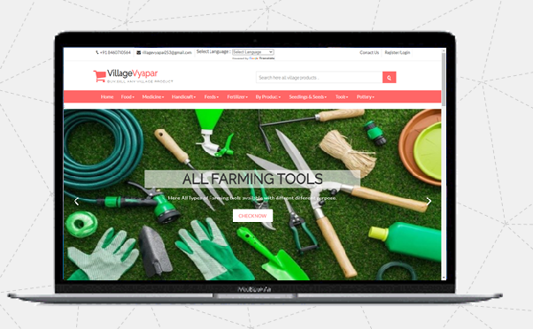

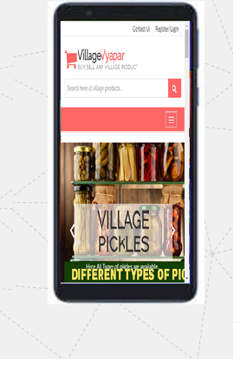

**Customer Side**

**Login and Registration page**

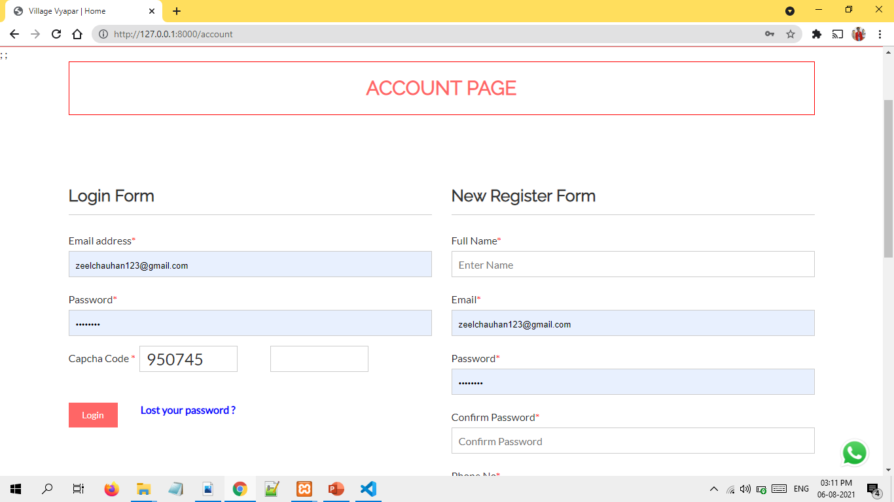

**Registration with invalid credentials**

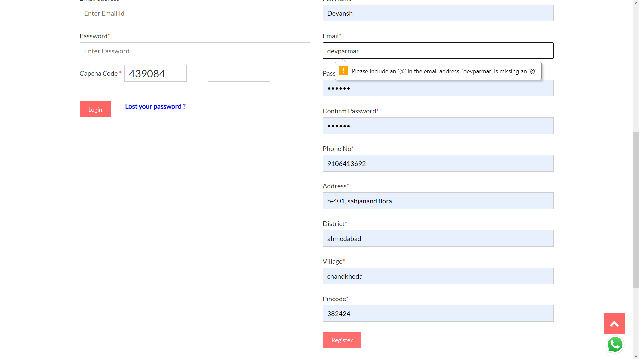

**Registration with existing email**

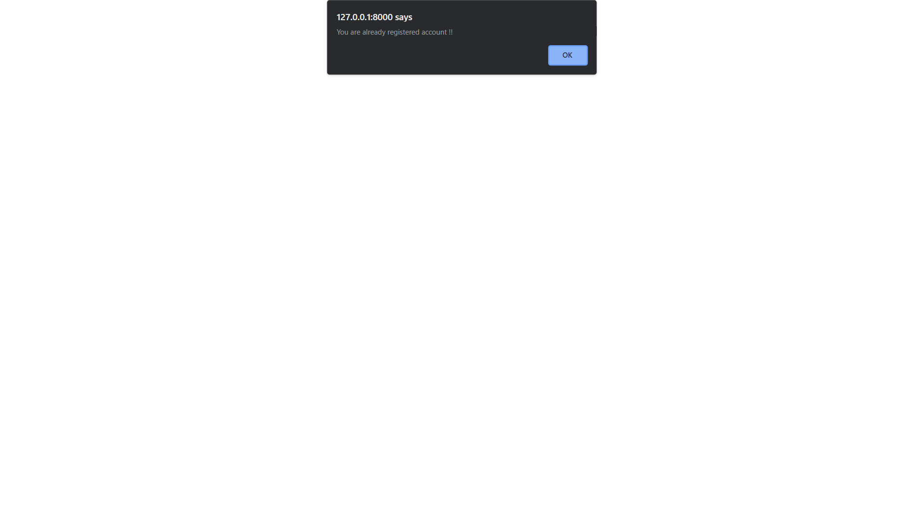

**OTP sent at email on New Registration**

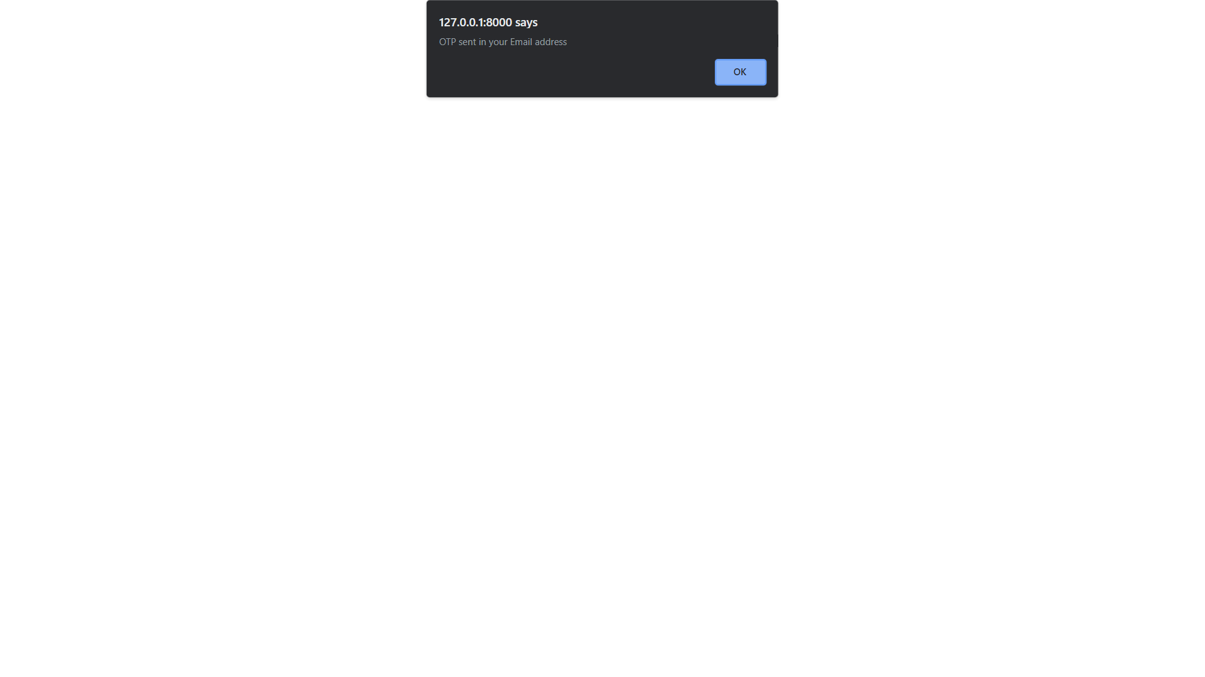

**OTP sent at email on New Registration**

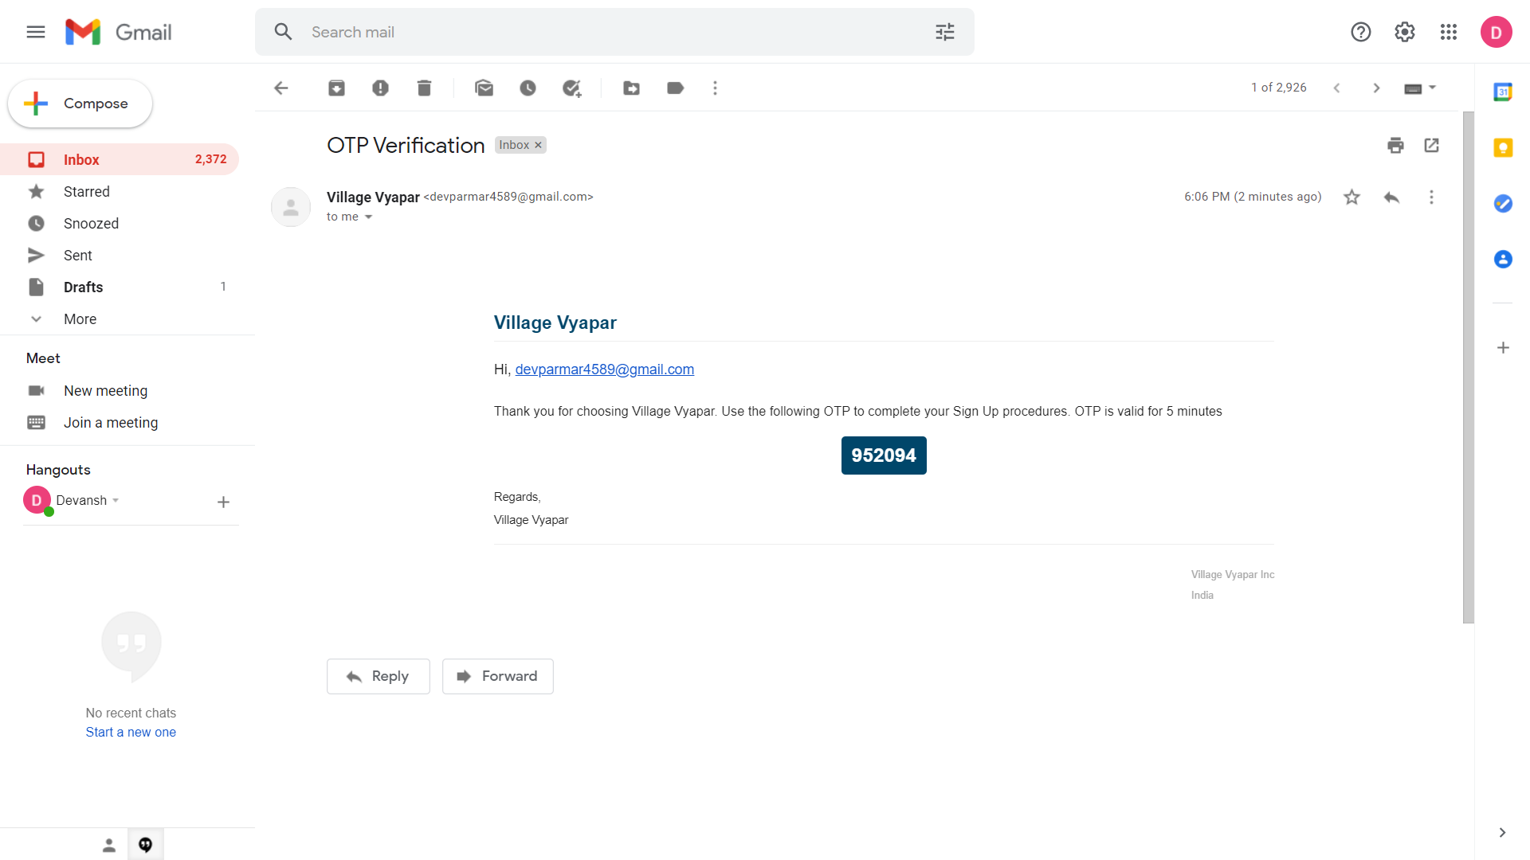

**Confirm OTP sent at email**

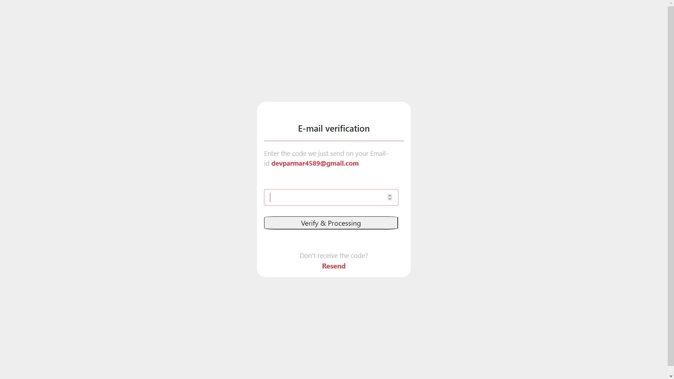

**Homepage**

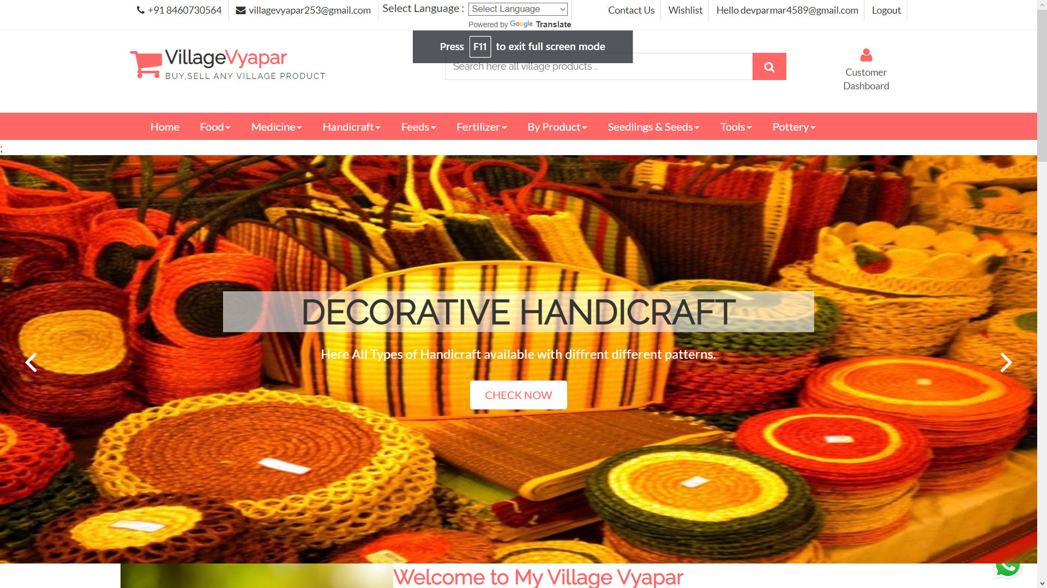

**Login Page**



**Login with invalid credentials**

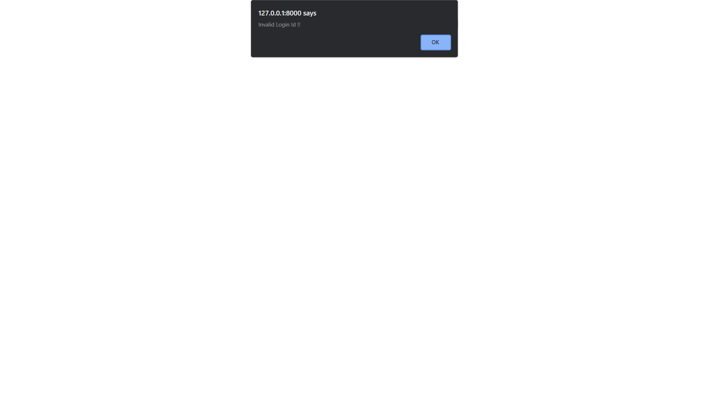

**Forgot password**

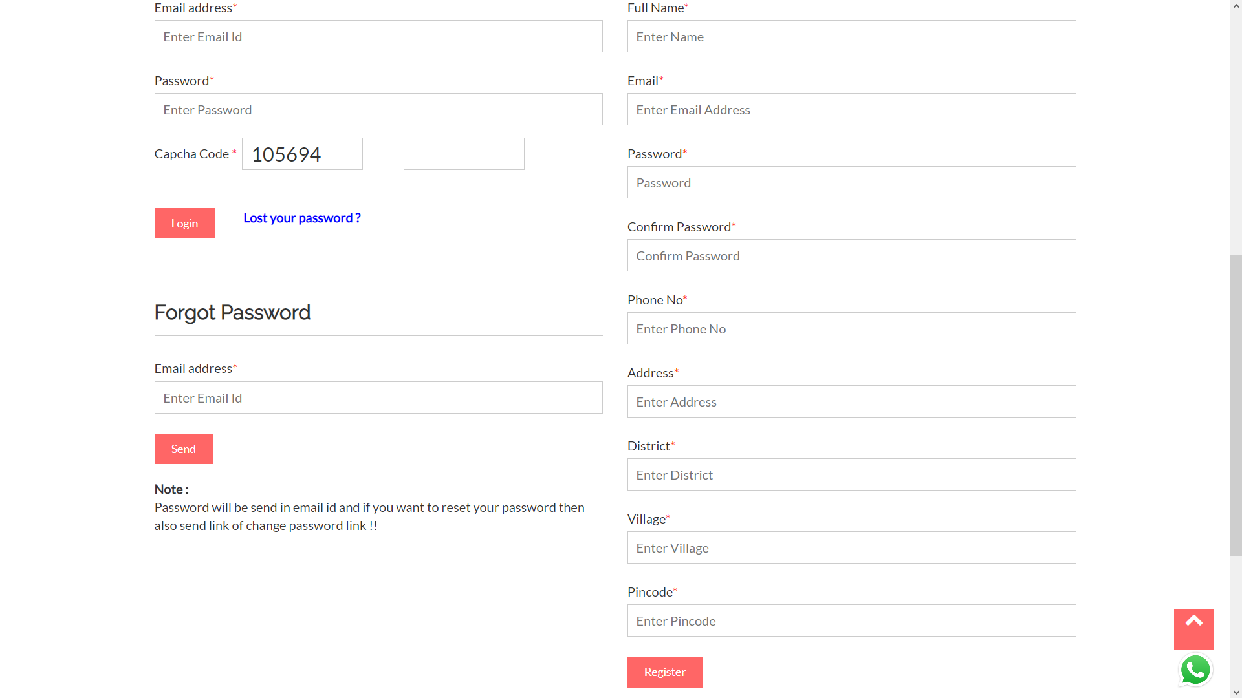

**Lost password sent at email address**

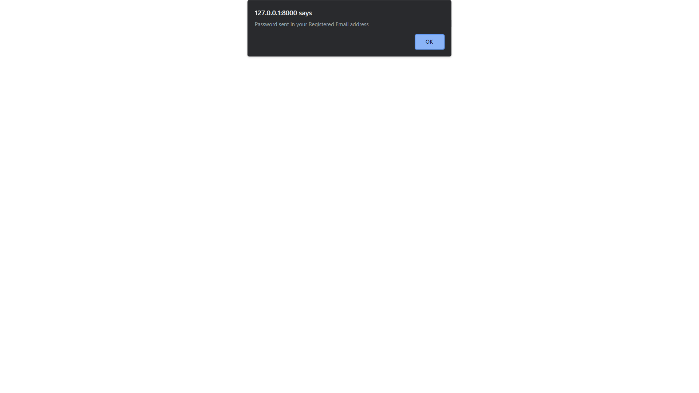

**Email sent for lost password**

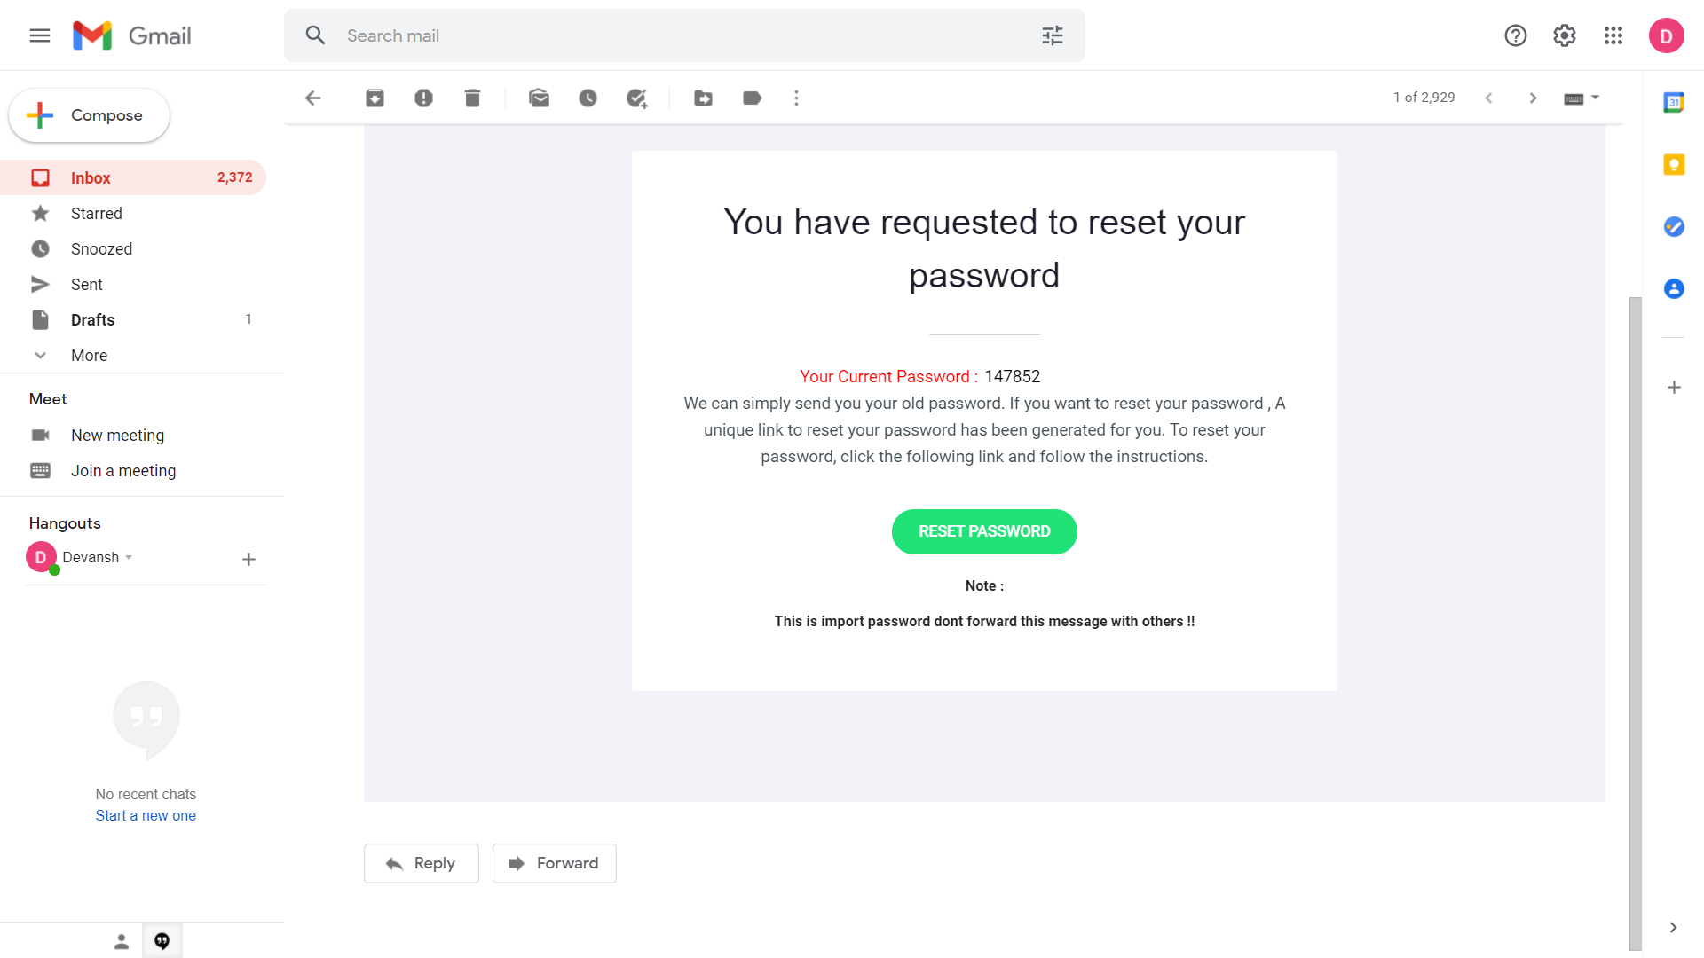

**Welcome page**

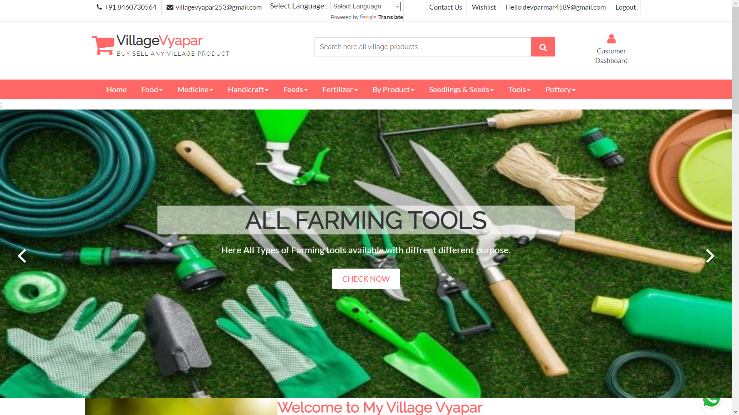

**Welcome page**

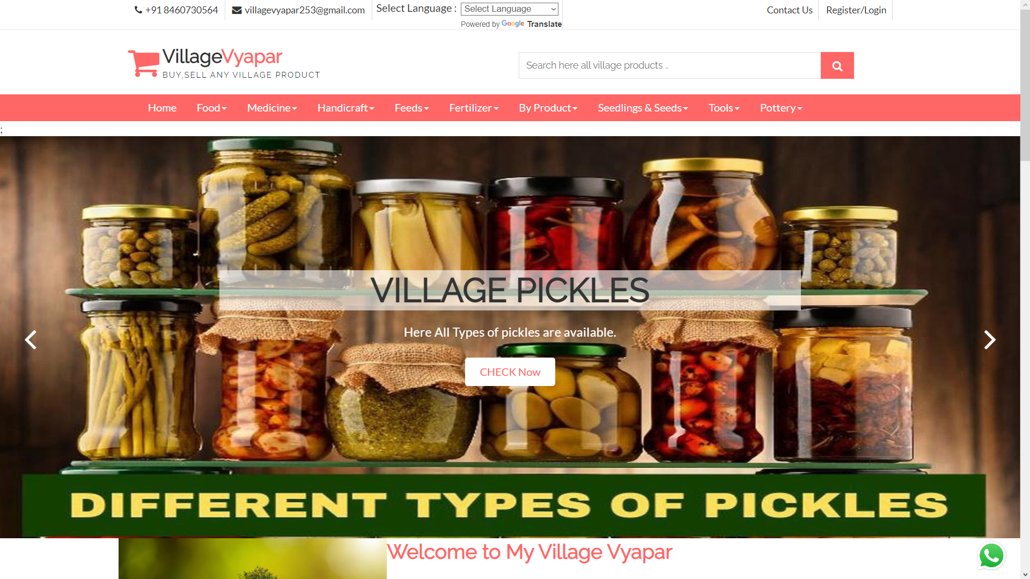

**Welcome page**

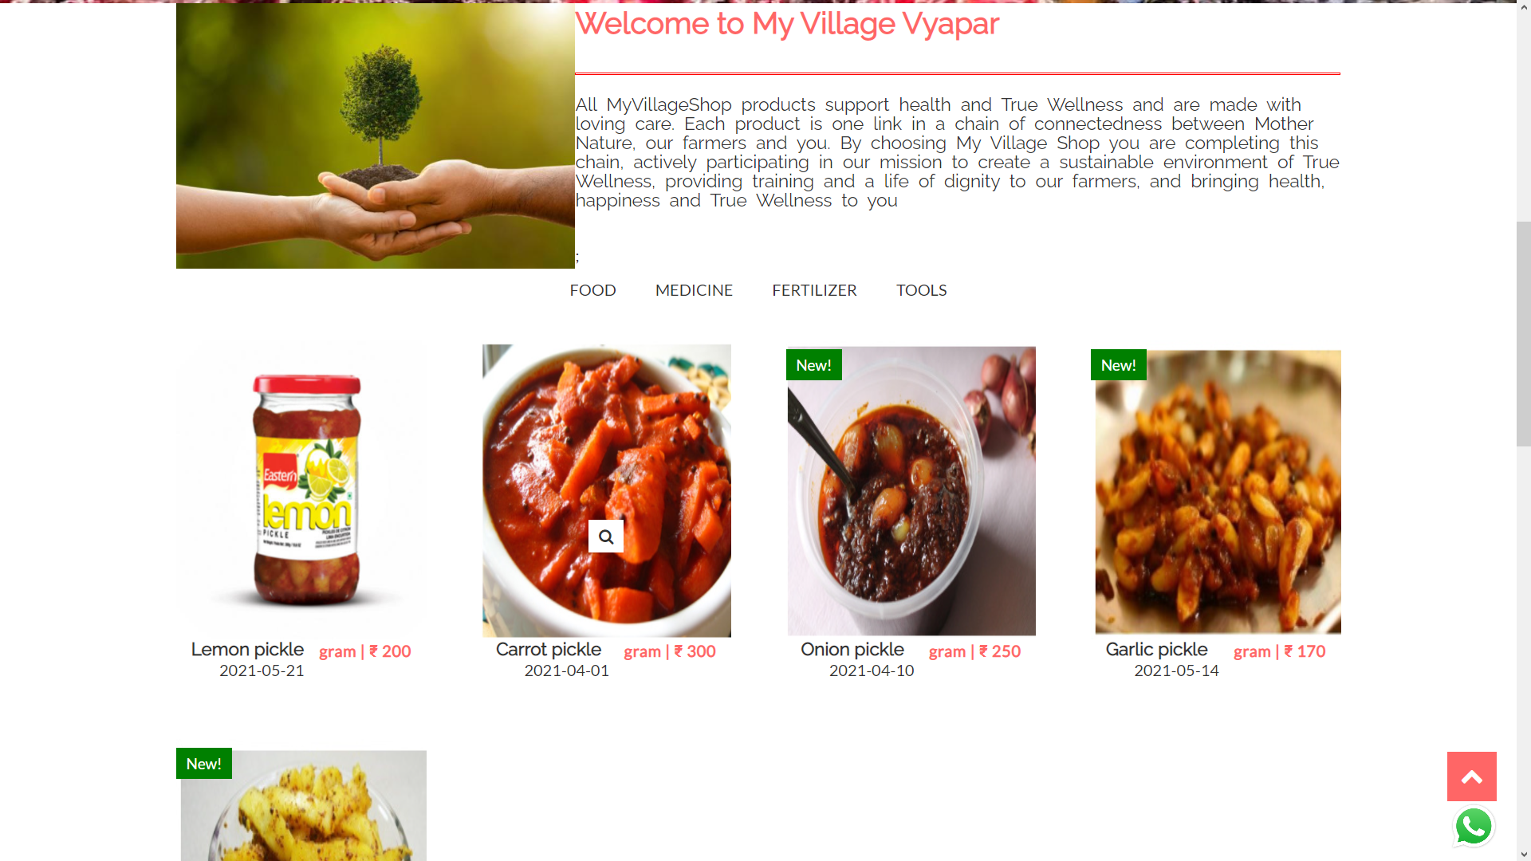

**Popular products**

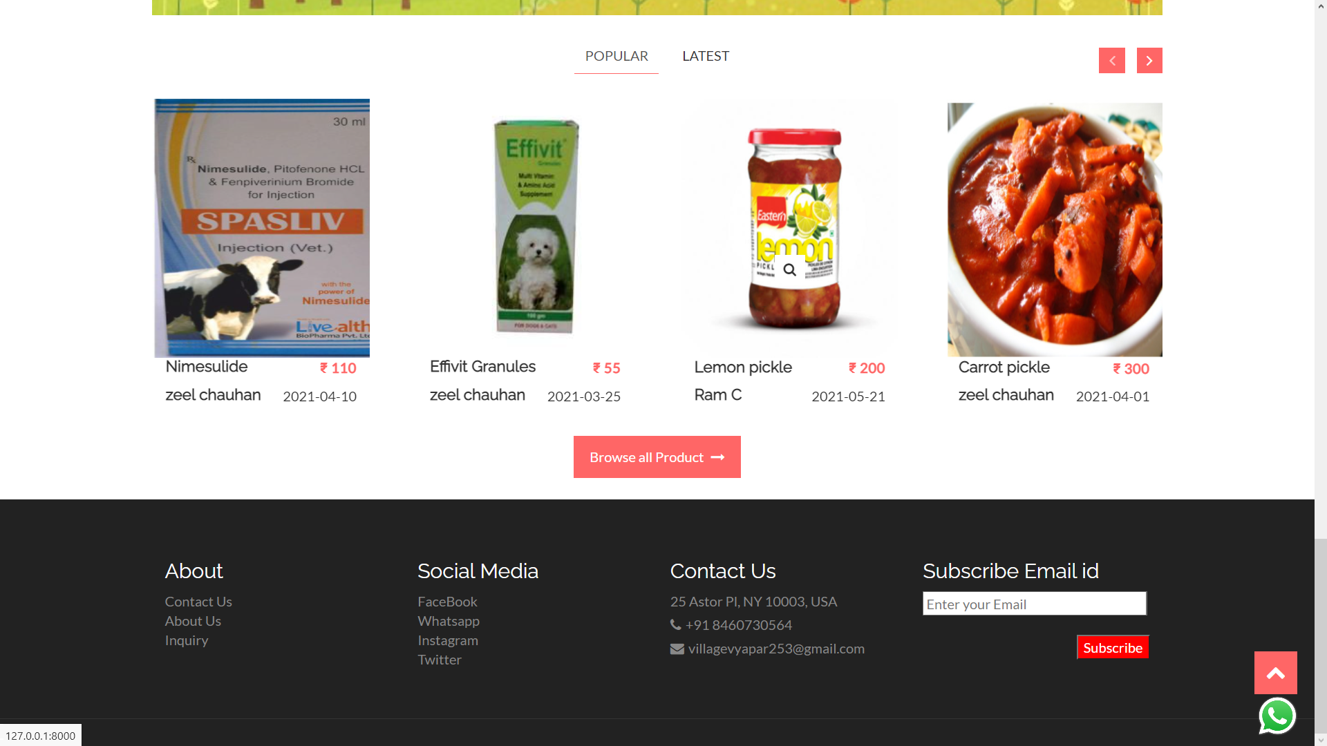

**Latest products**

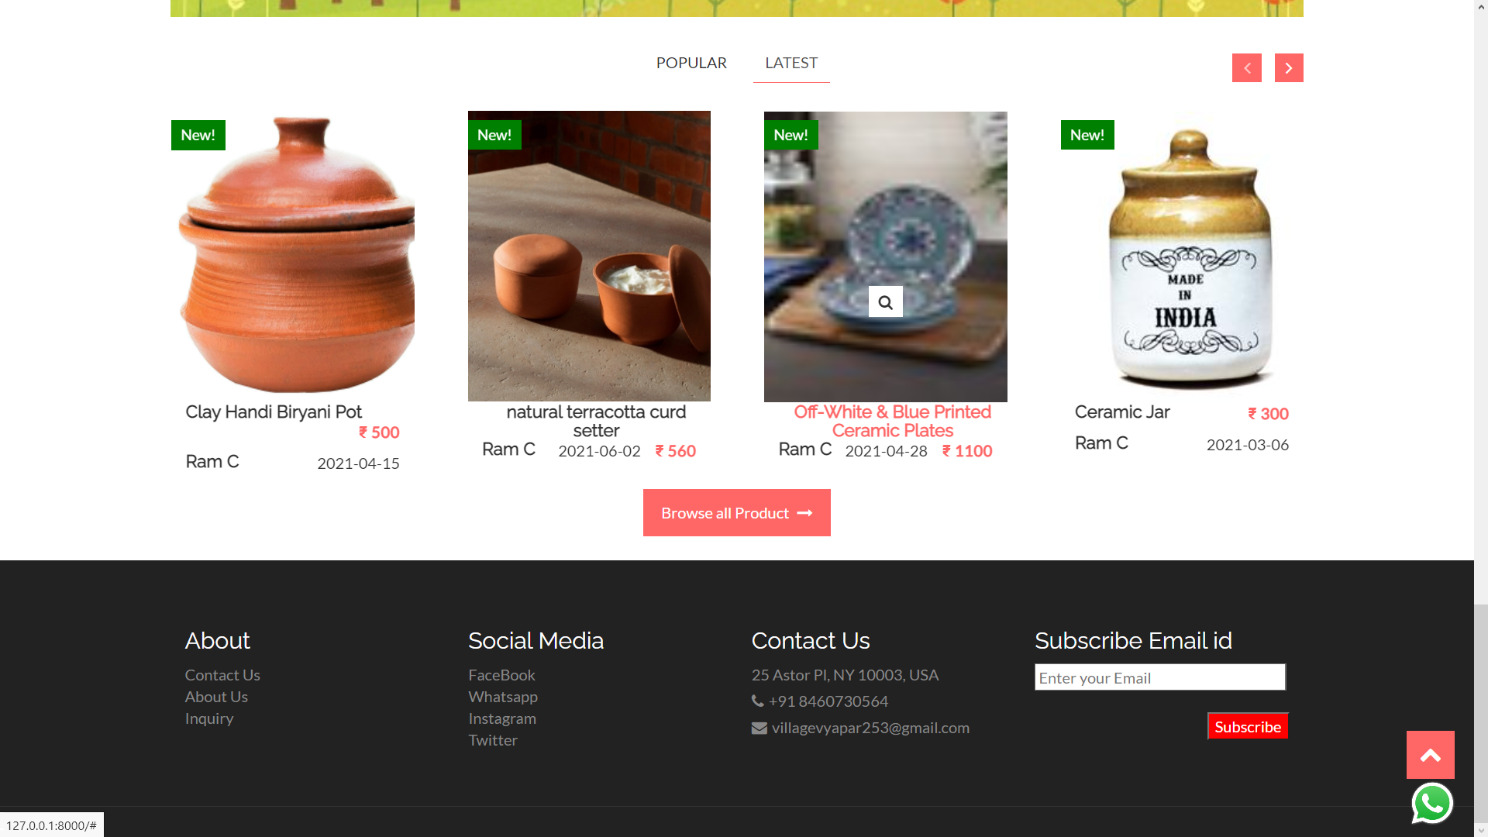

**Products within subcategories**

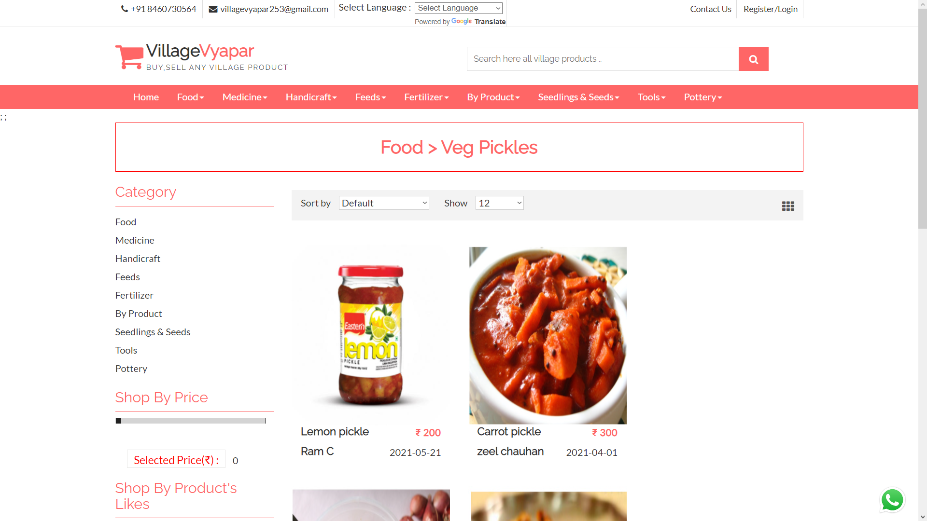

**Products limited with price**

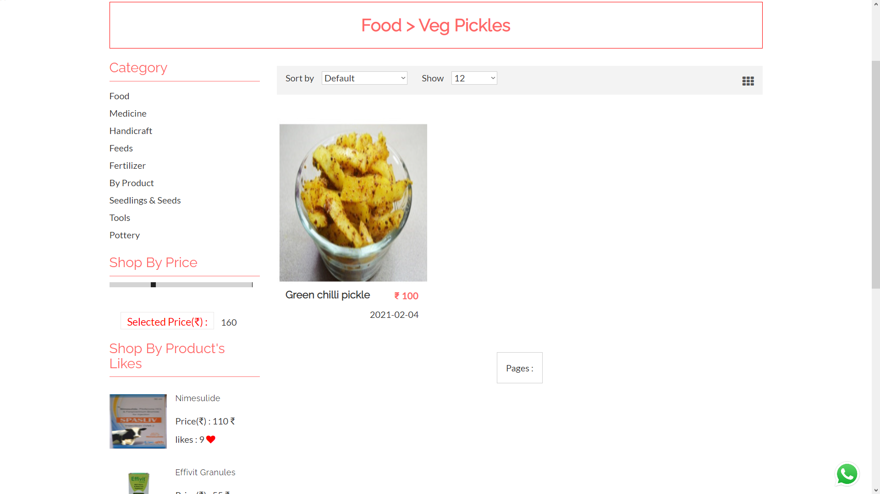

**Product detail Model**

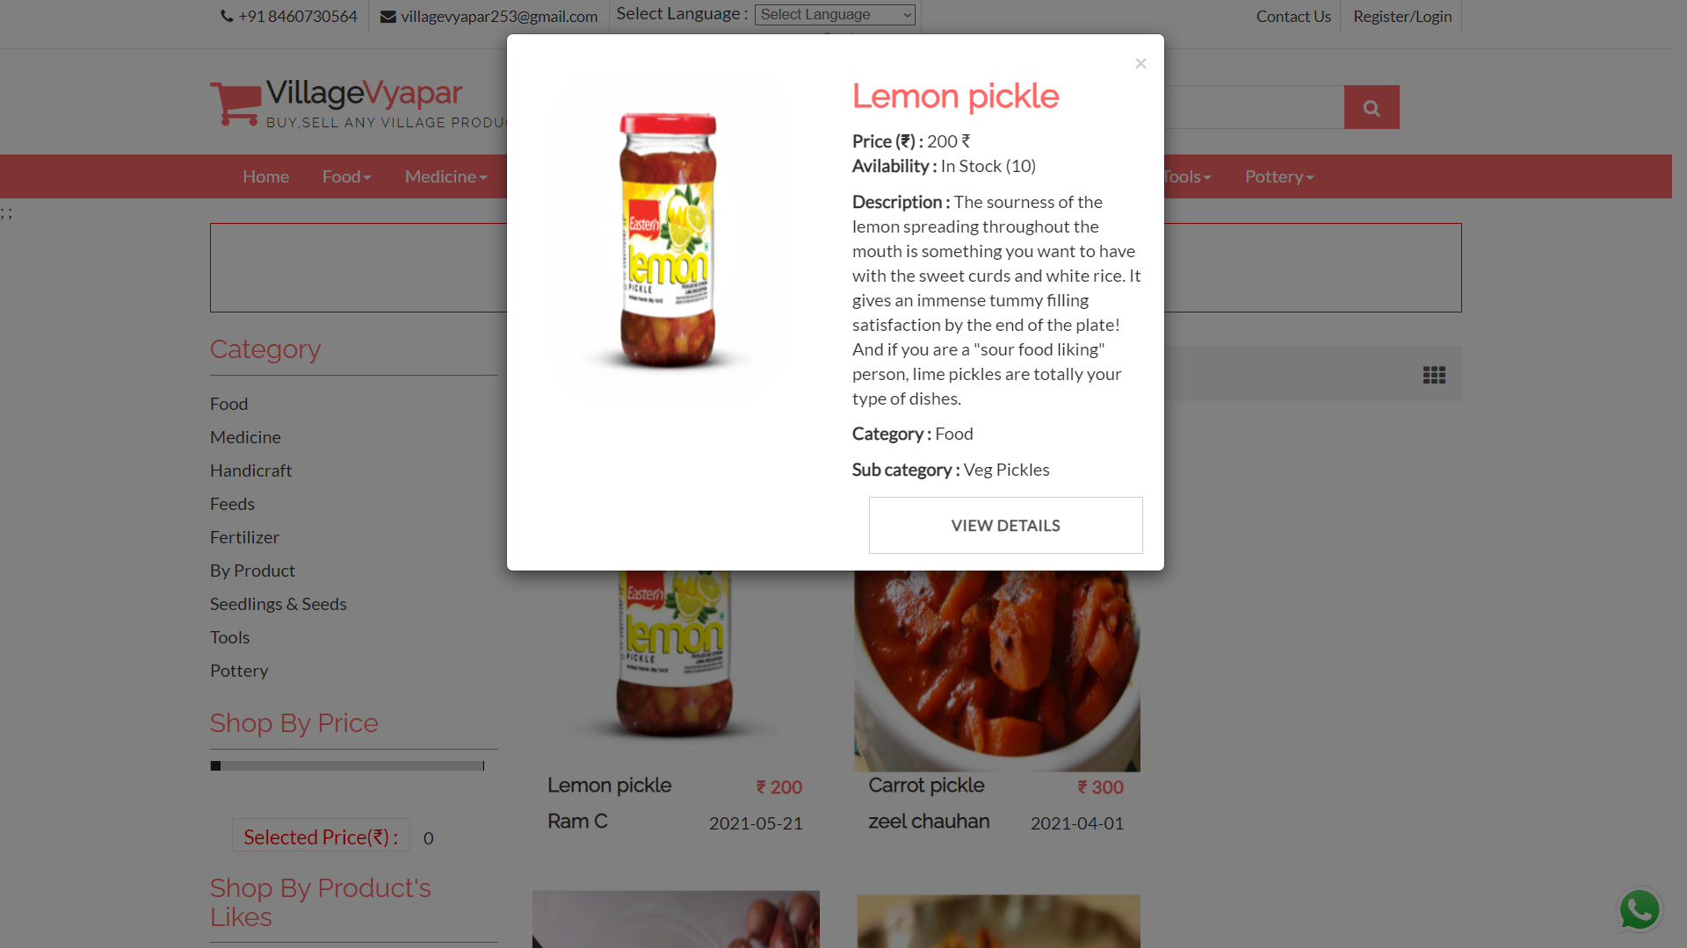

**Product details**

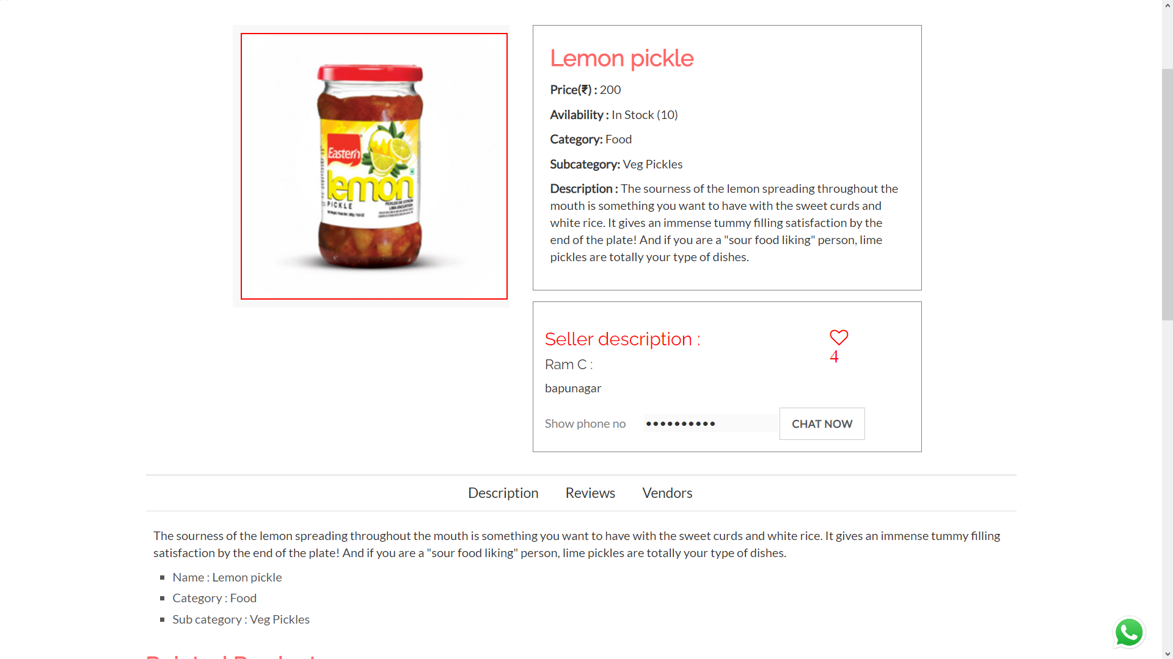

**Product image zoomed**

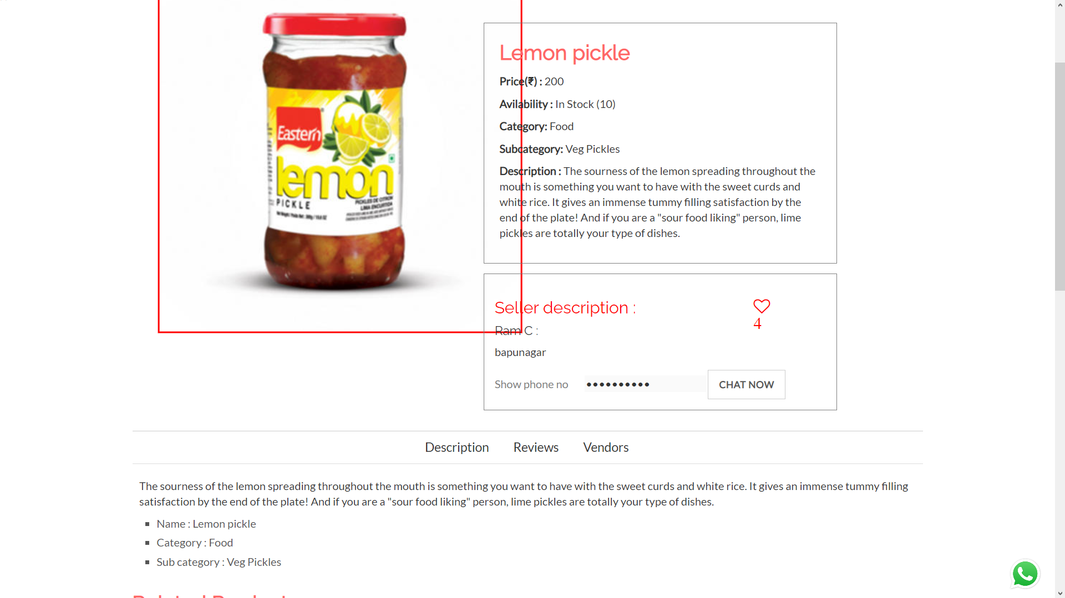

**Product reviews**

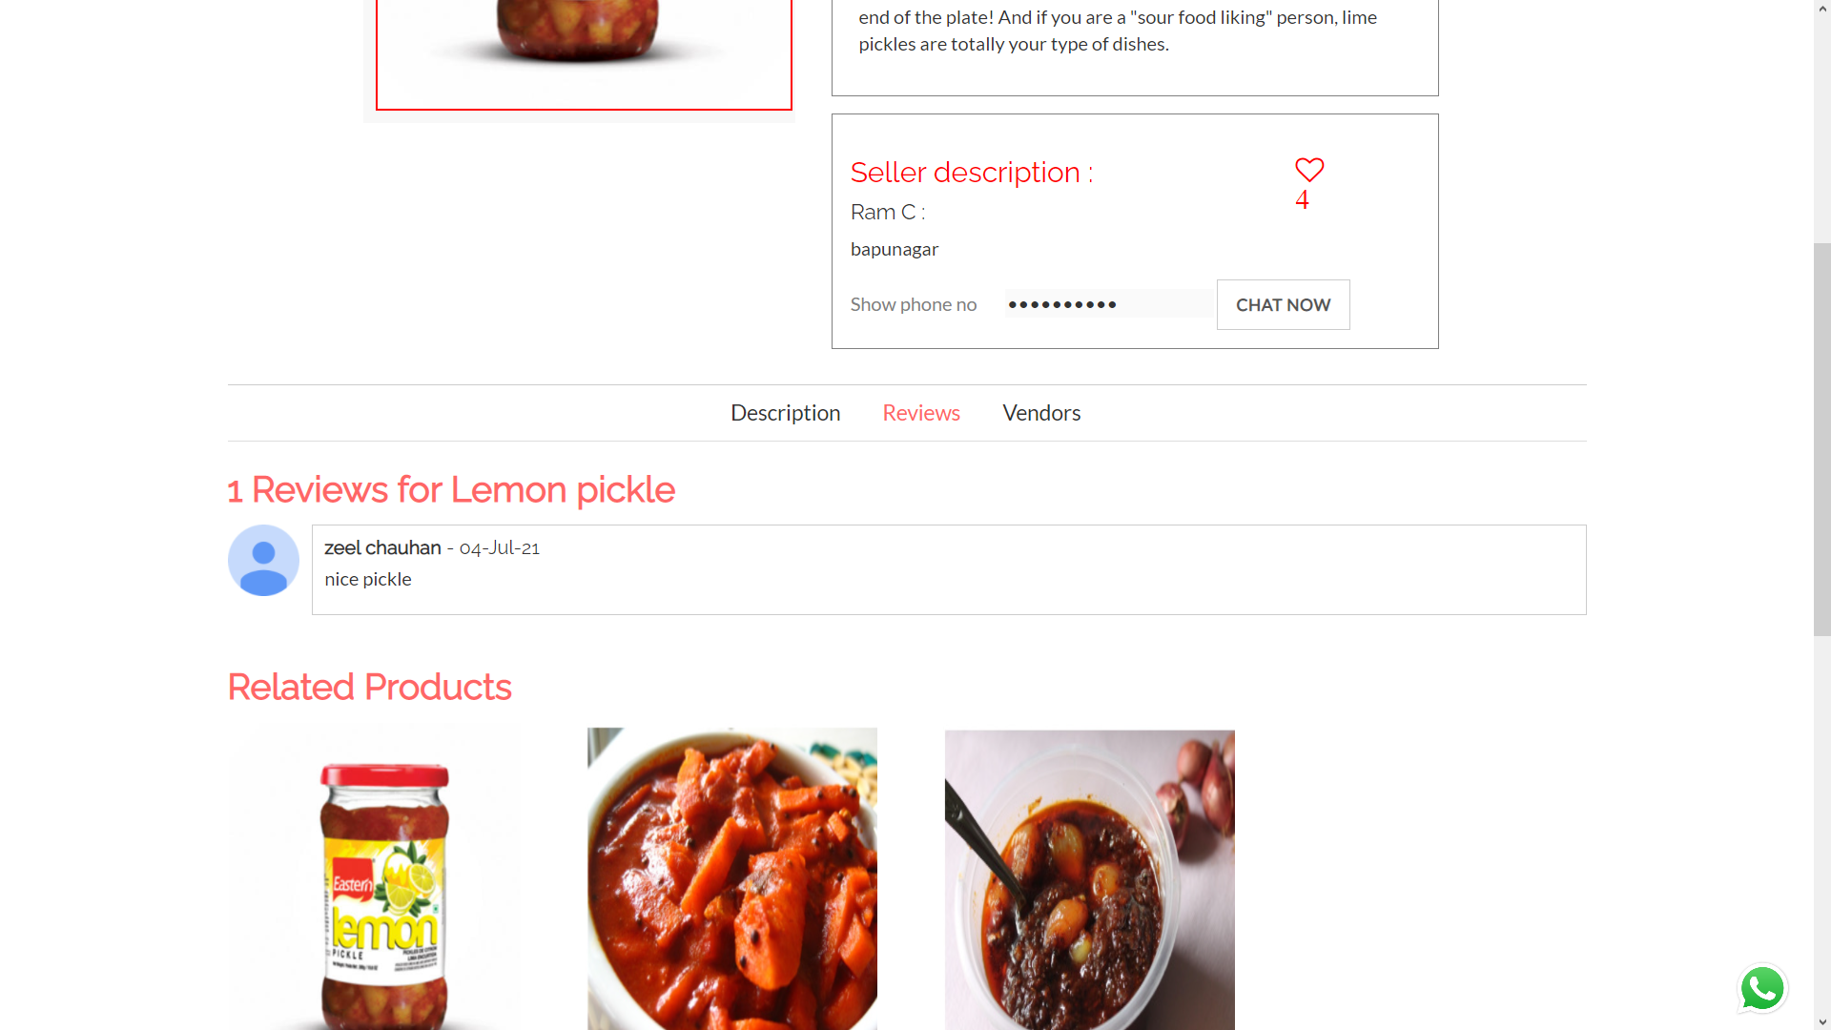

**Vendor information**

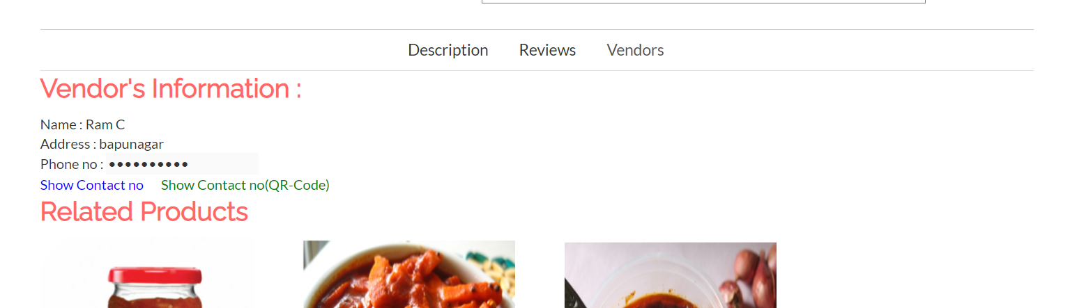

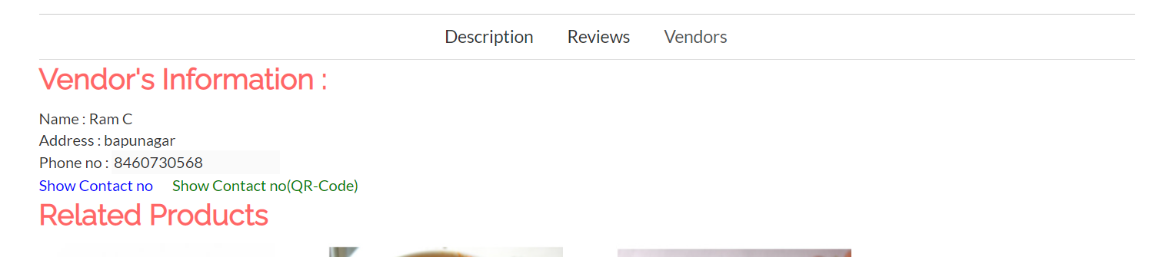

**Vendor info 2**

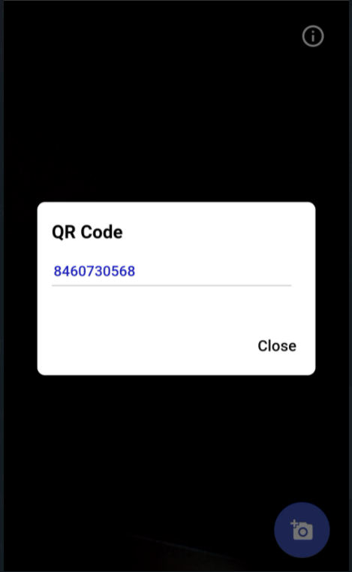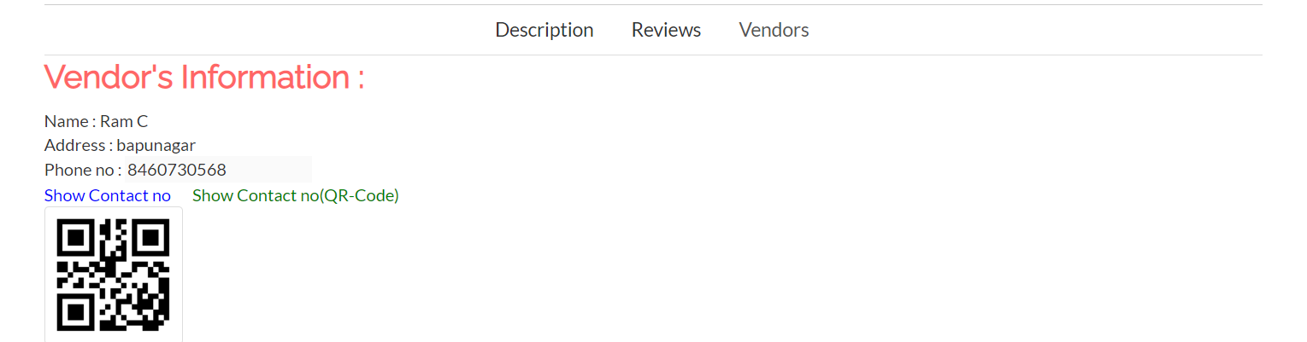

**Contact us**

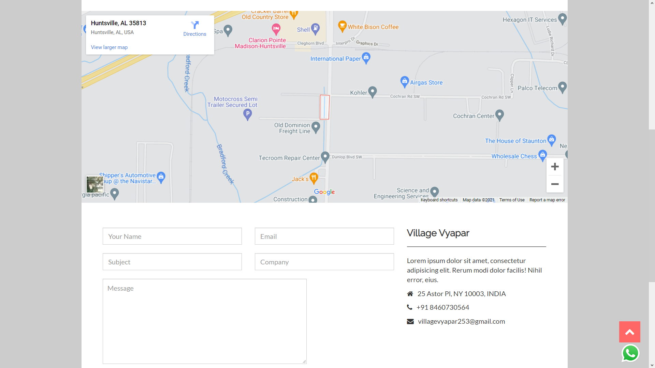

Inquiry

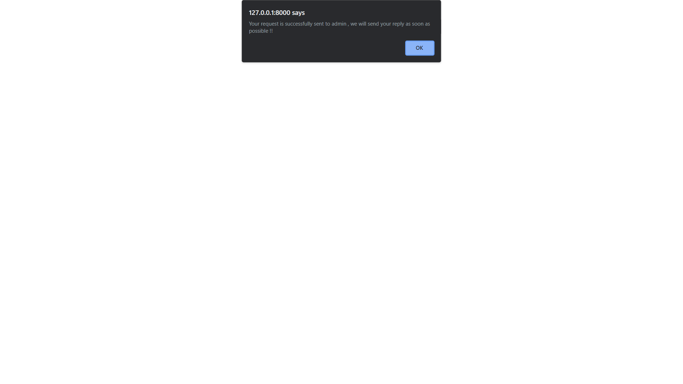

**Language changes**

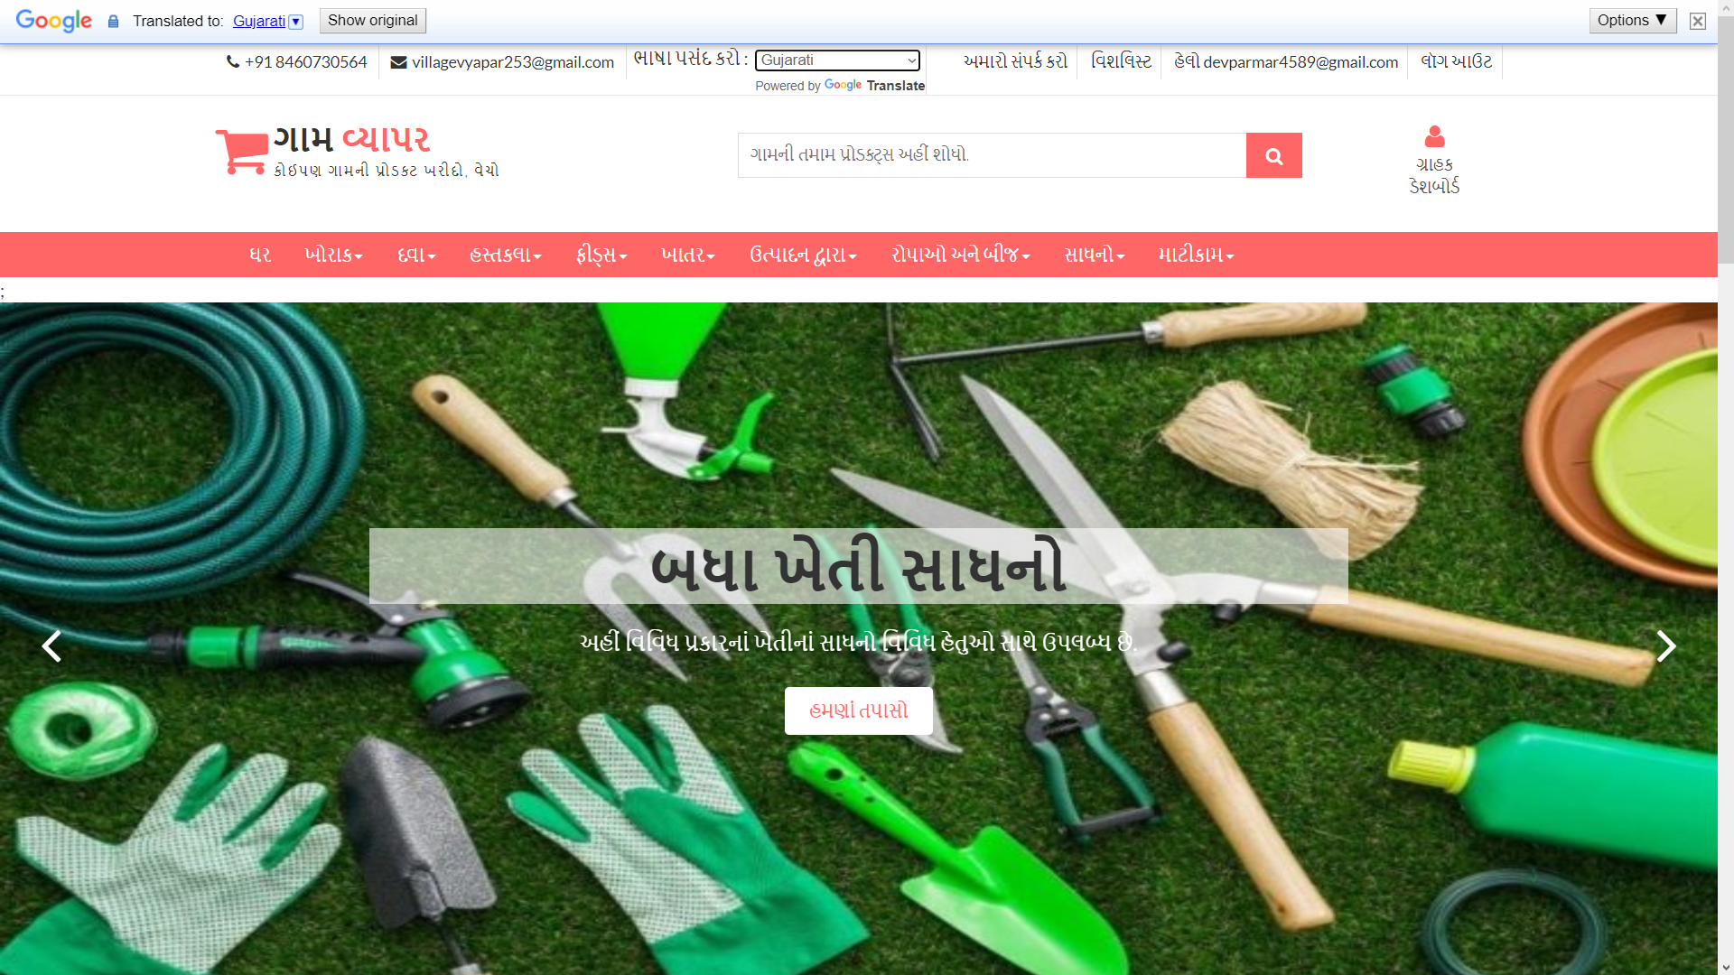

**Language changes**

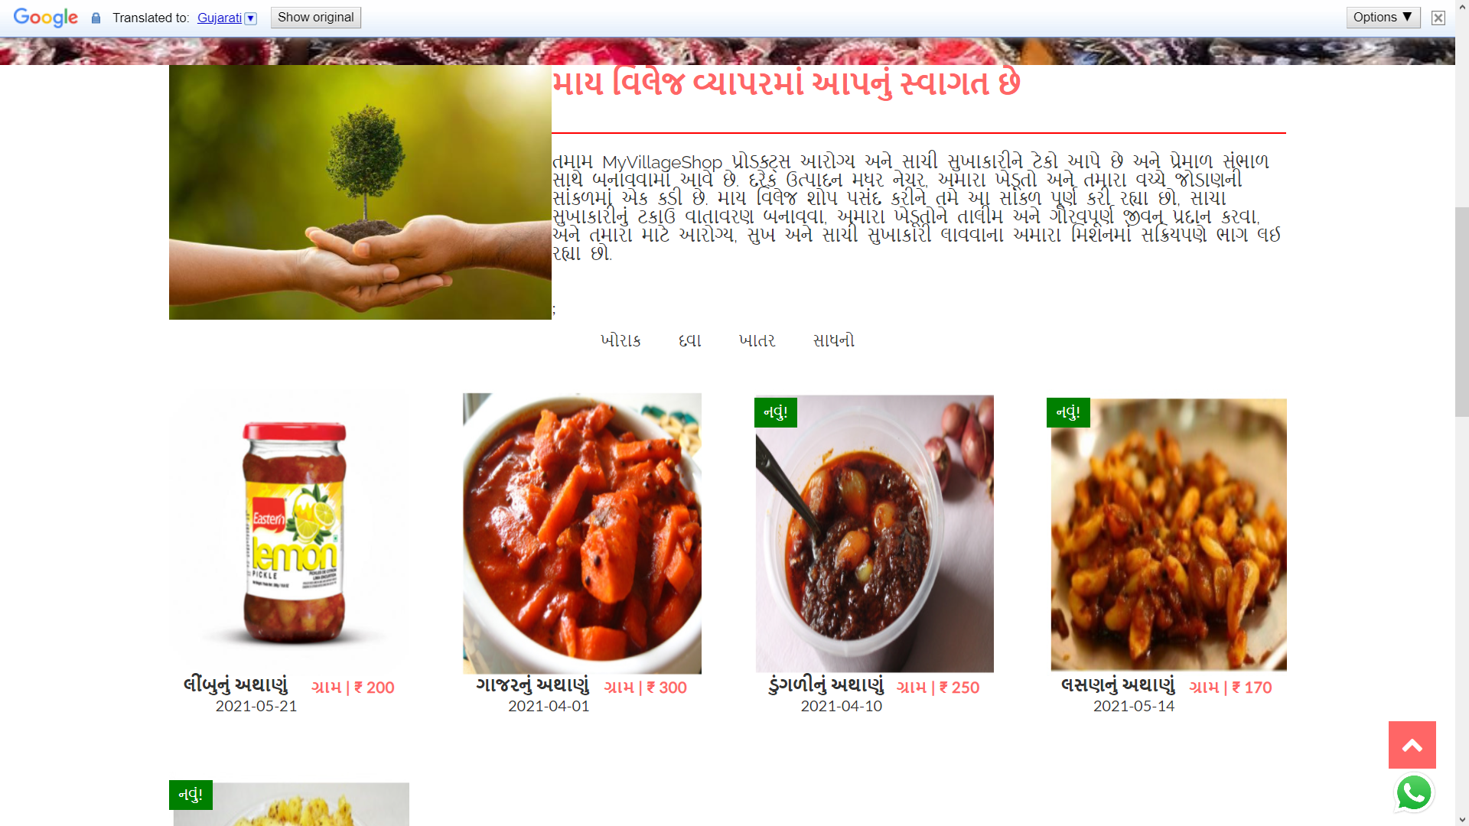

**Language changes**

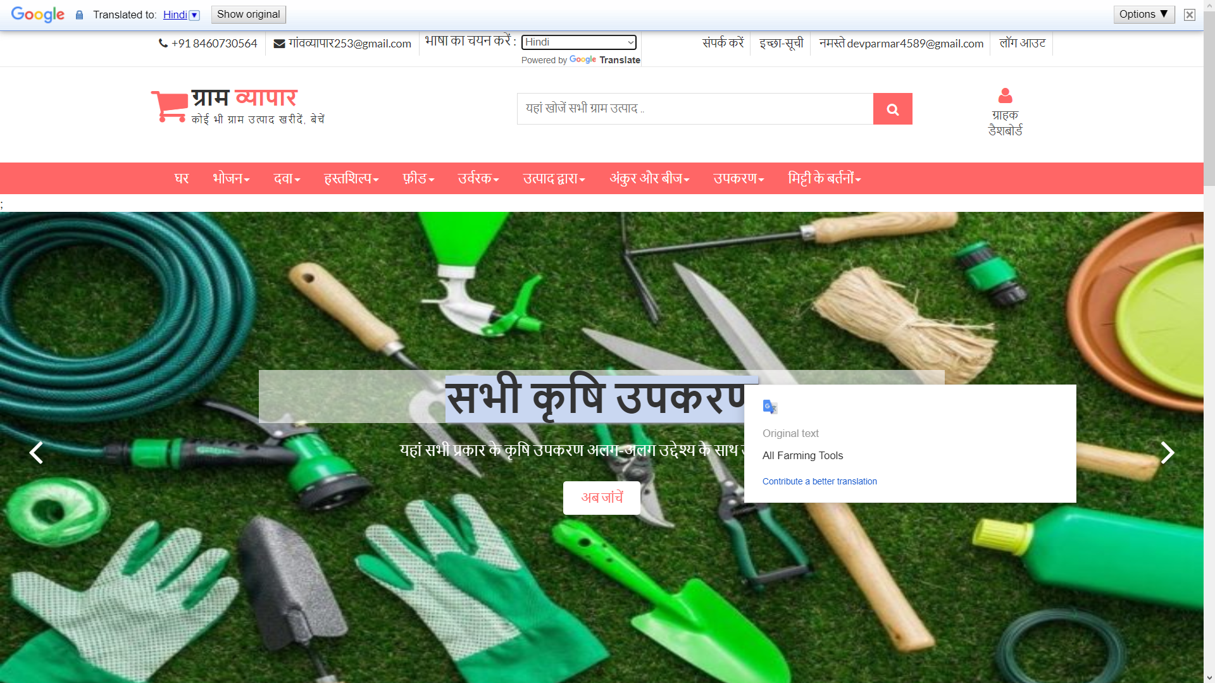

**Language changes**

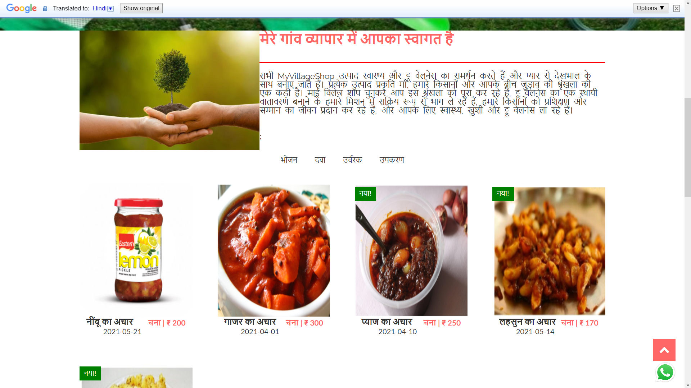

**Login**



**Customer Dashboard**

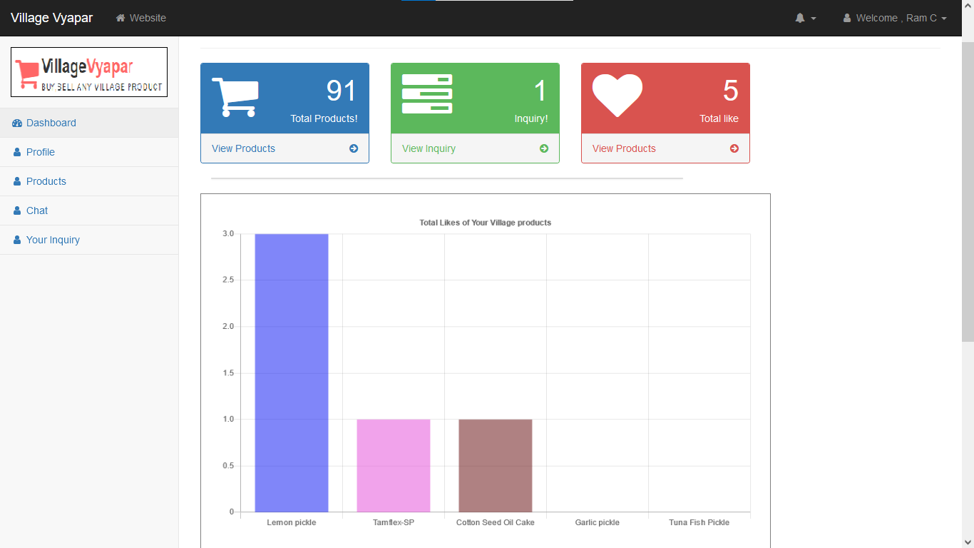

**Total Likes of customer products**

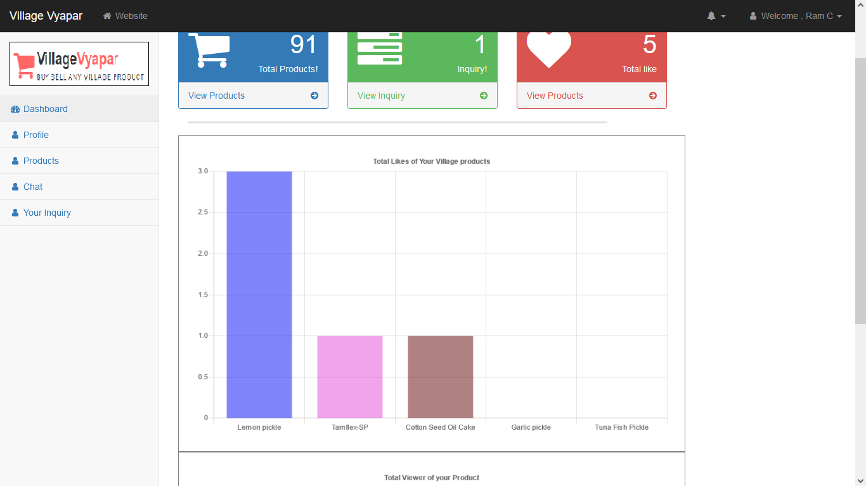

**Total Viewer of customer products**

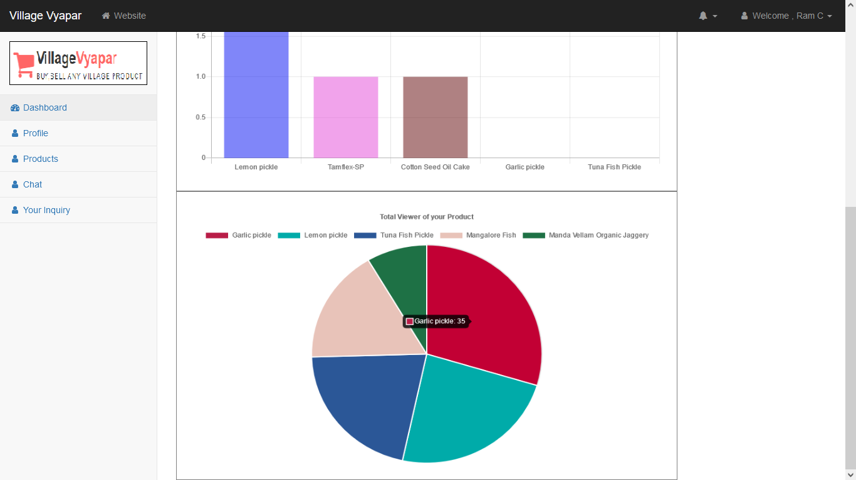

**Customer Profile**

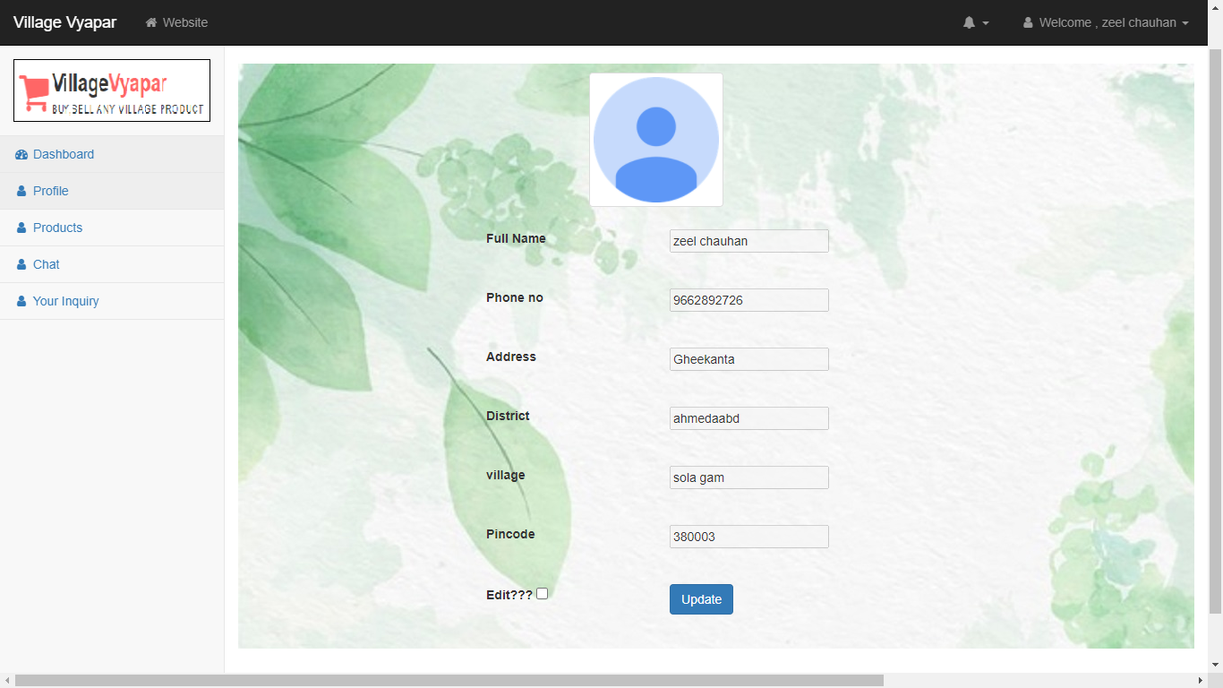

**Update Customer Profile**



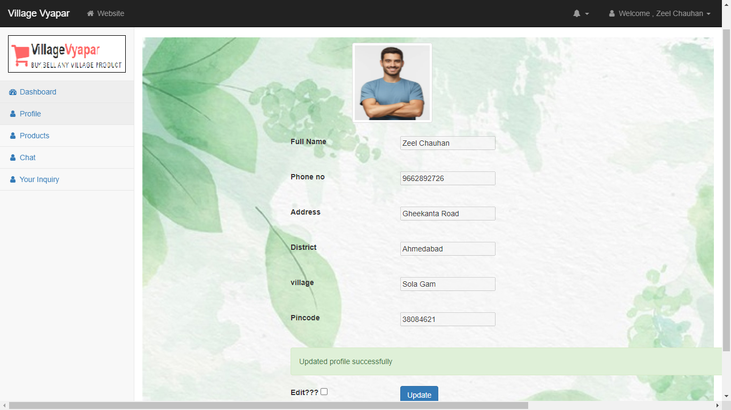

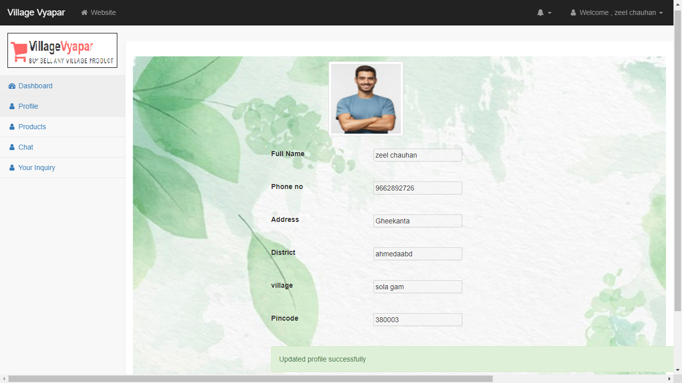

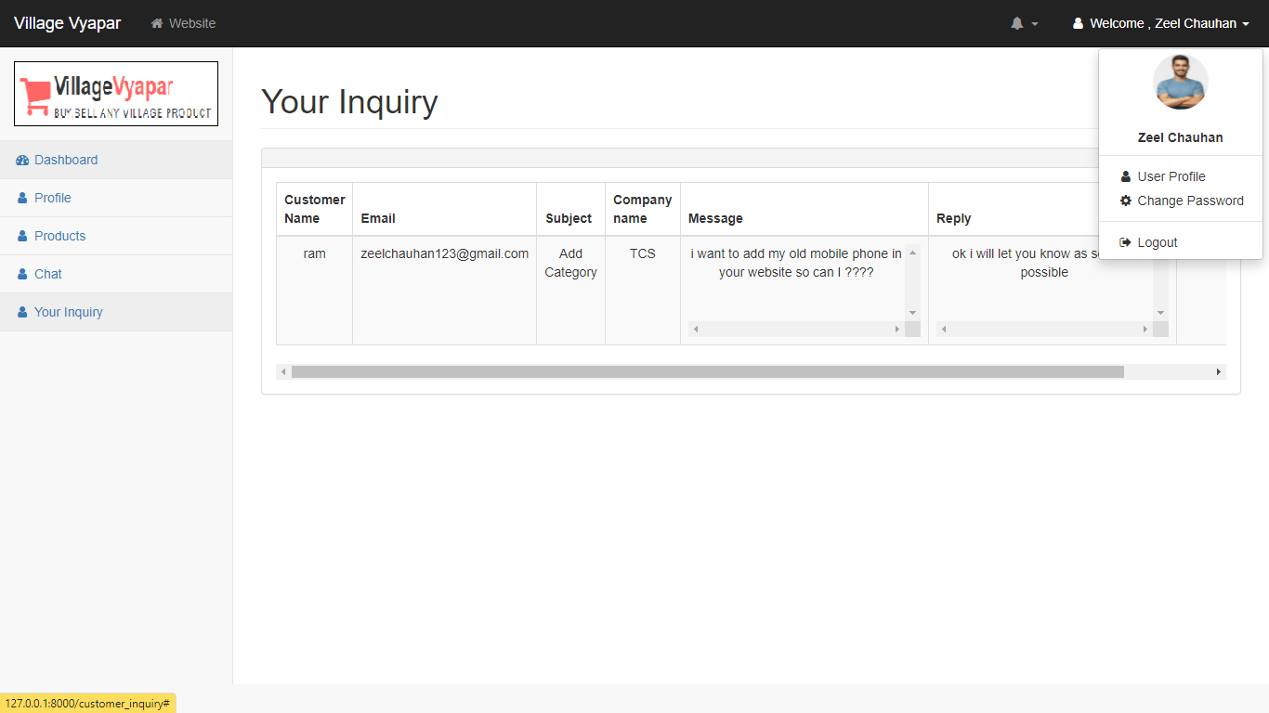

**Change Password**

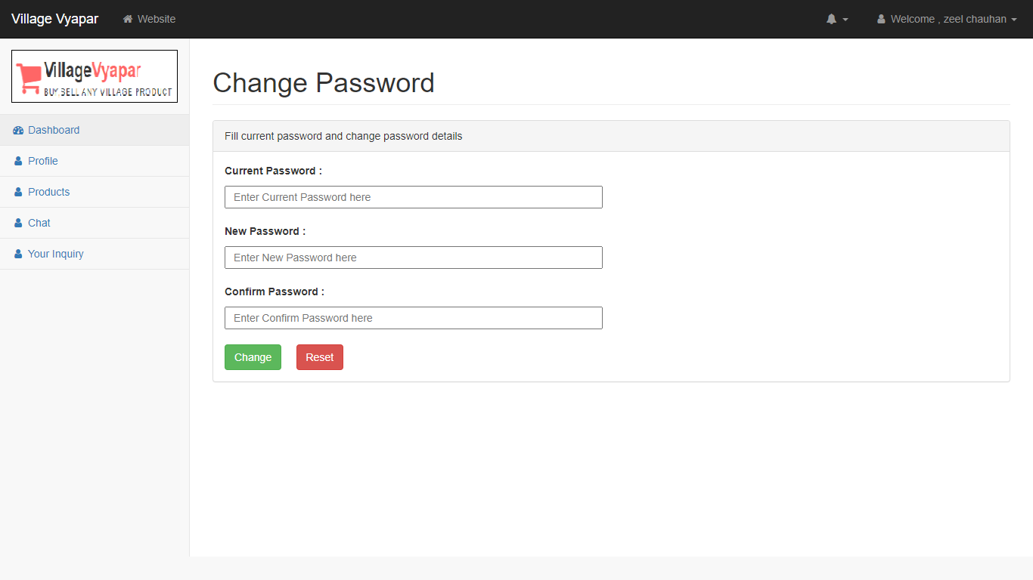

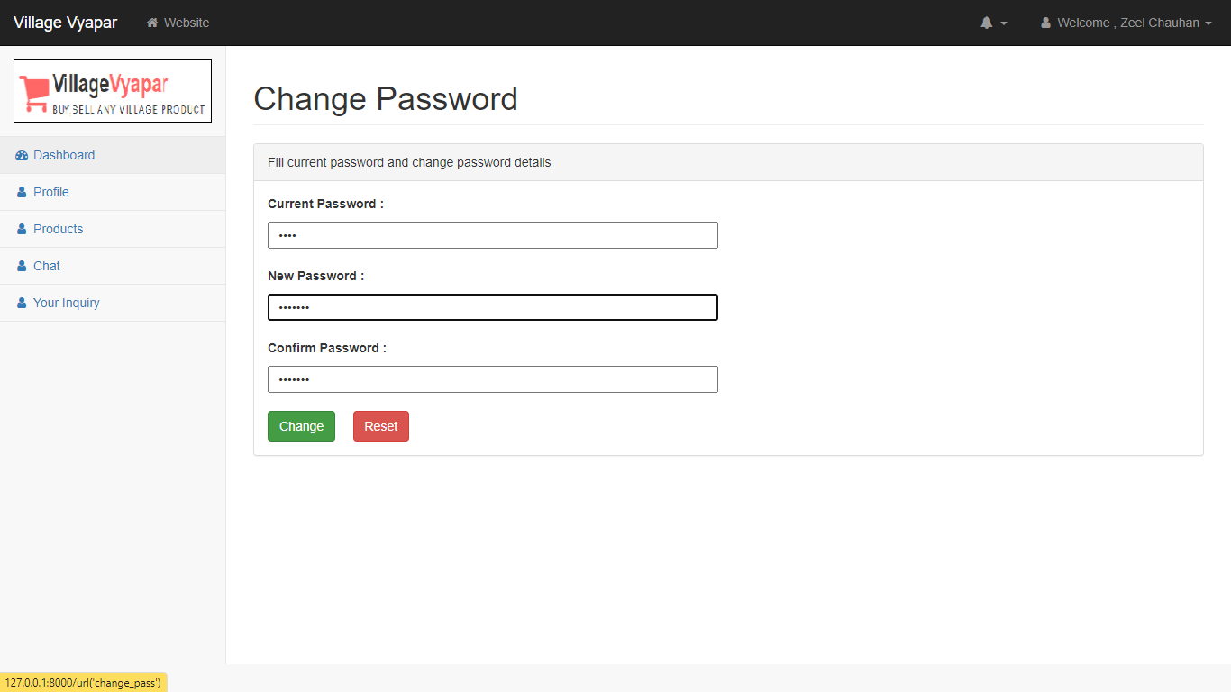

**View Products**

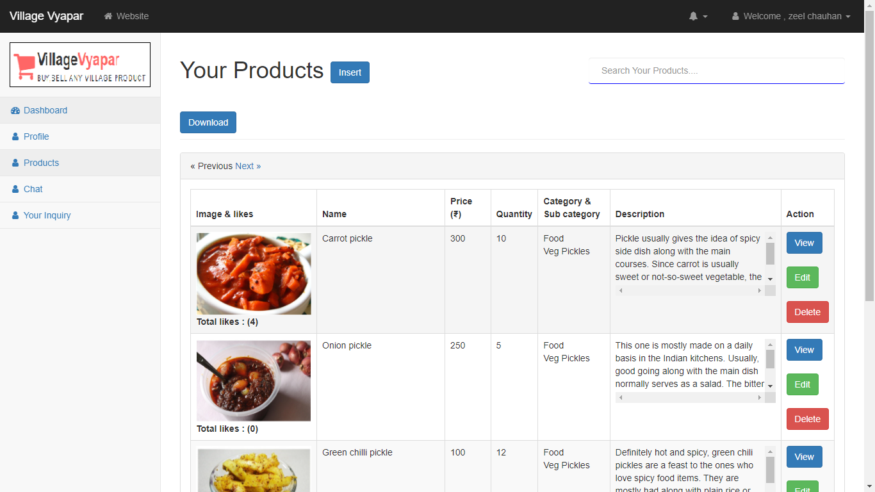

**Insert Product**

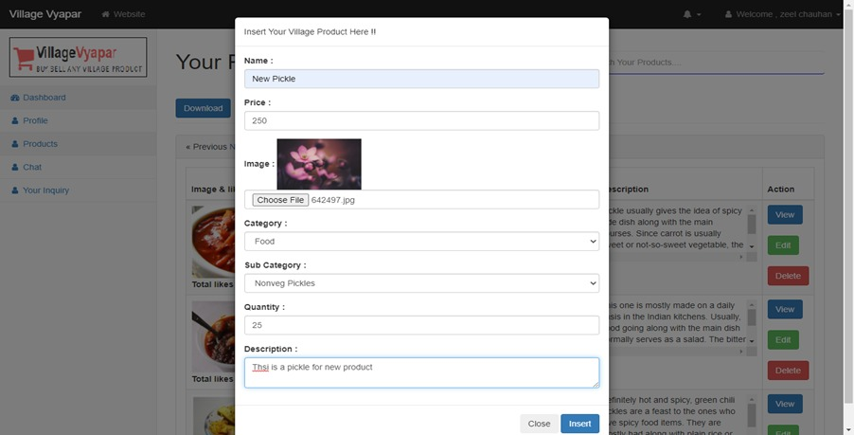

**Product Inserted**

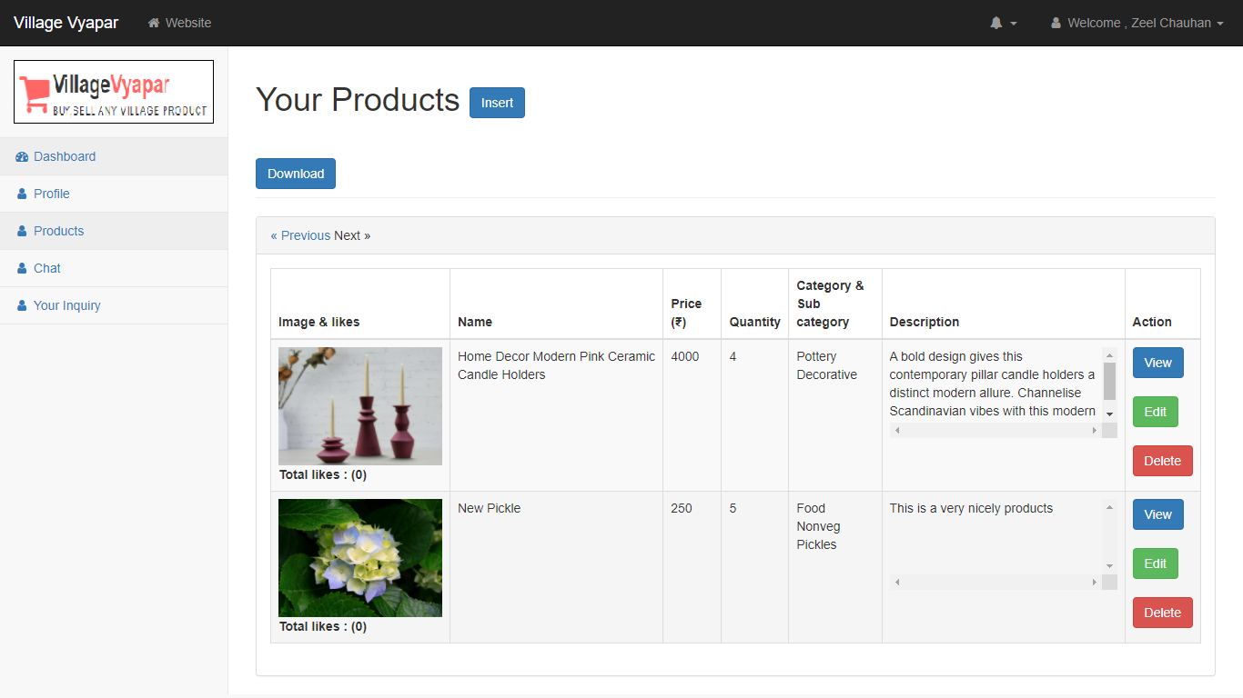

**Search Products**

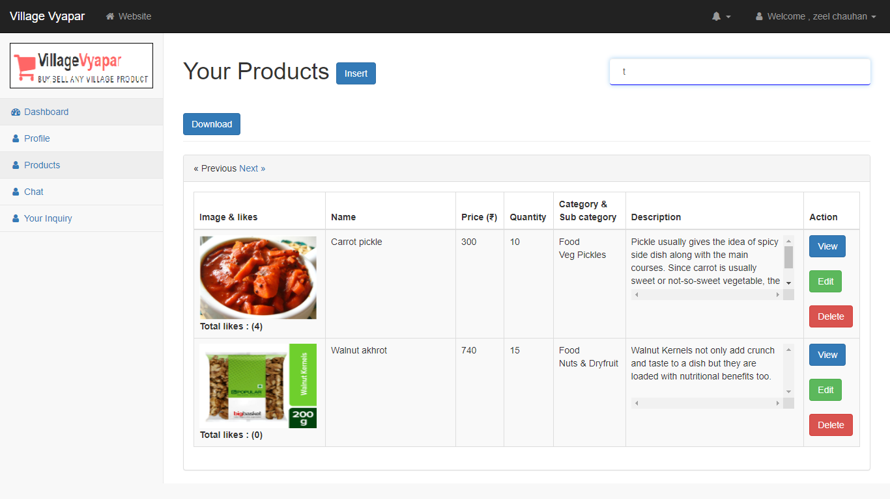

**View Product**

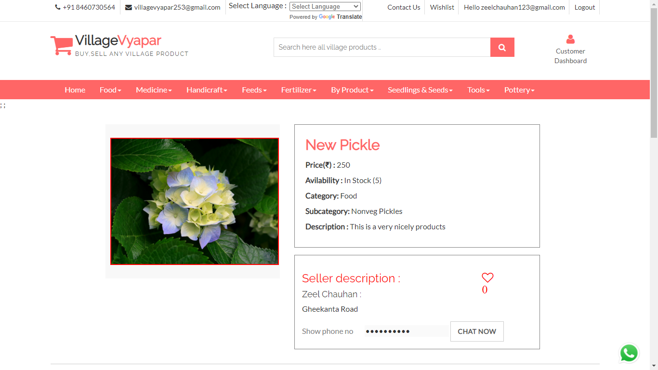

**Edit Product details**

**Delete Product**

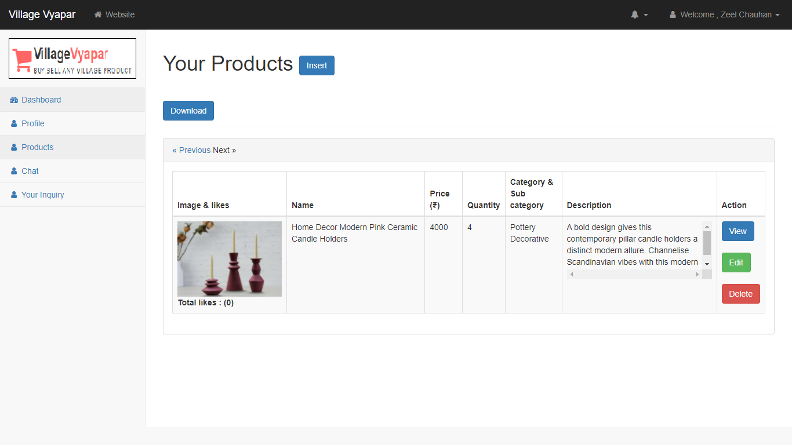

**Download Product (Pdf)**

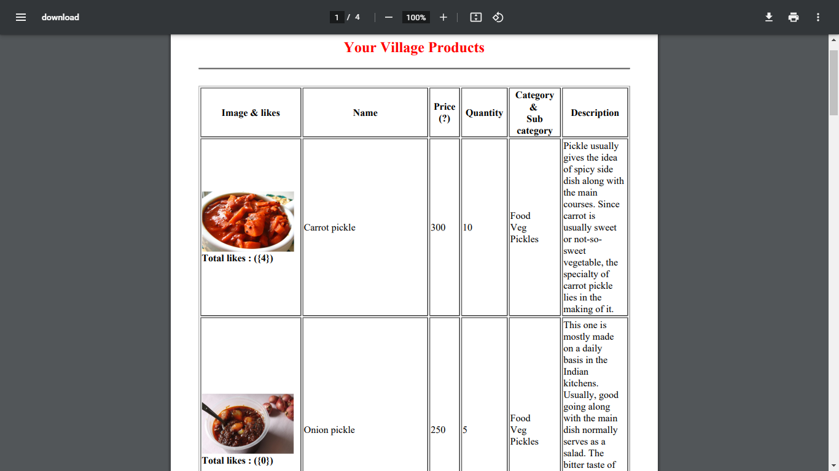

**Chat bot**

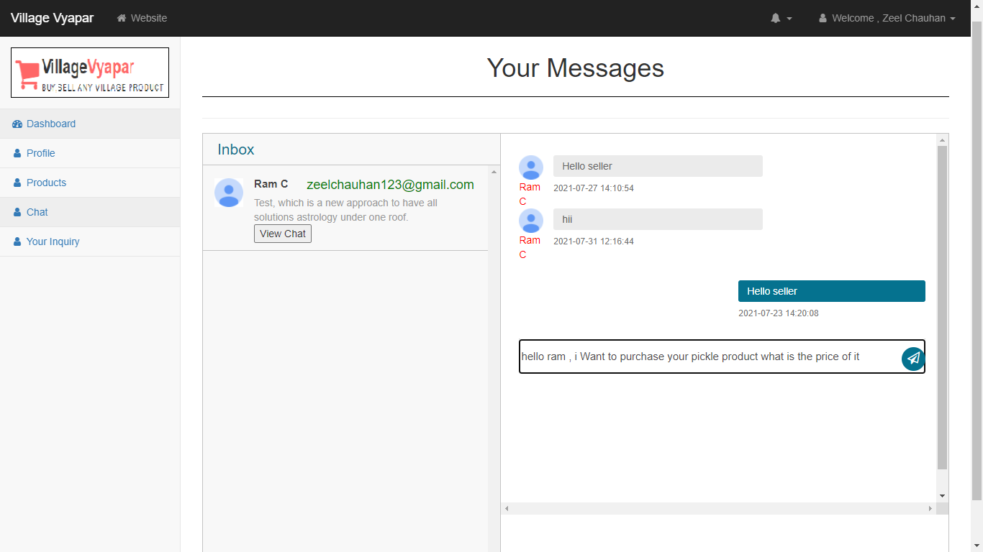

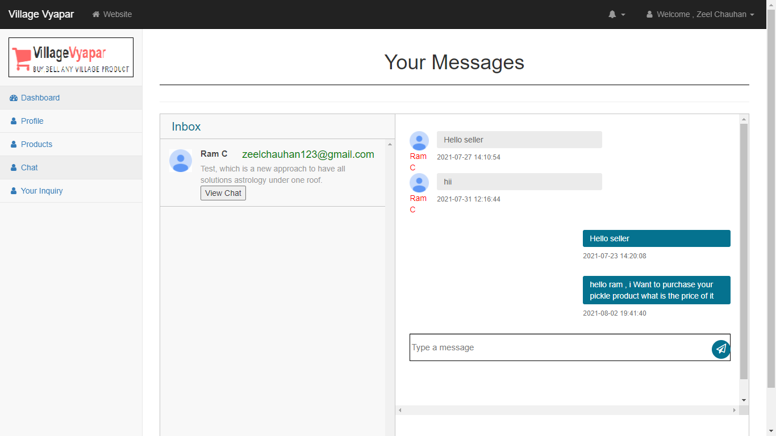

**Inquiry**

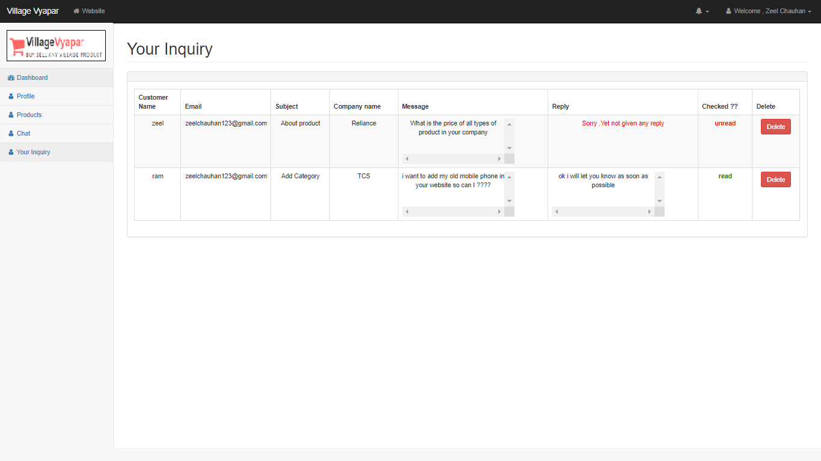

**Delete Inquiry**

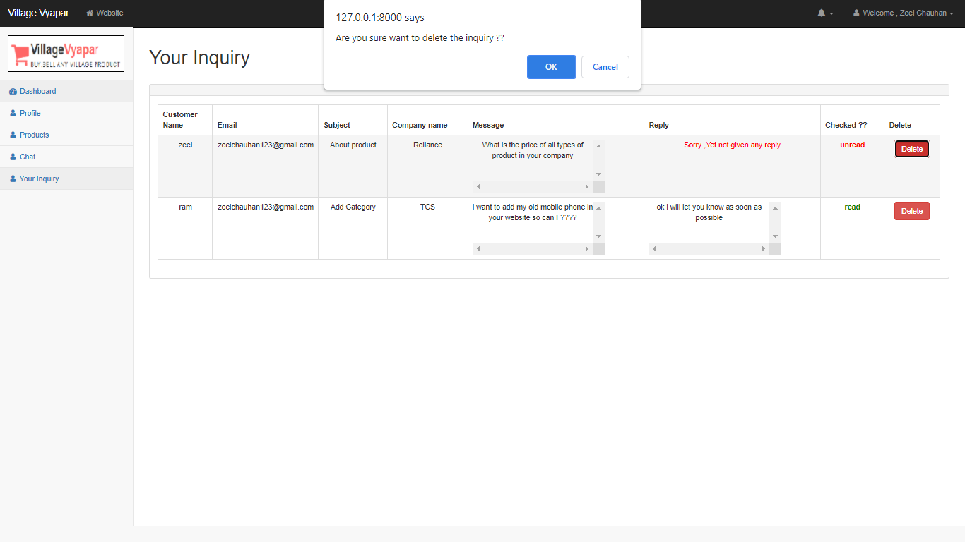

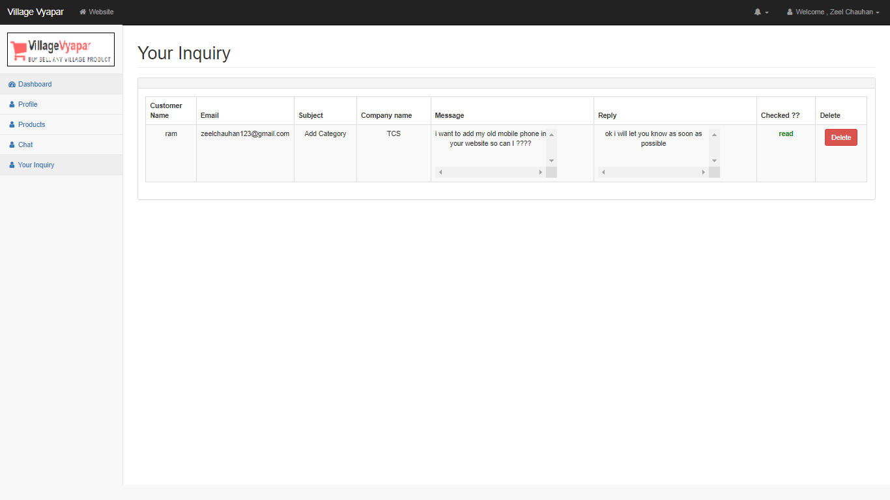

**Admin-Side**

**Admin-login Page**

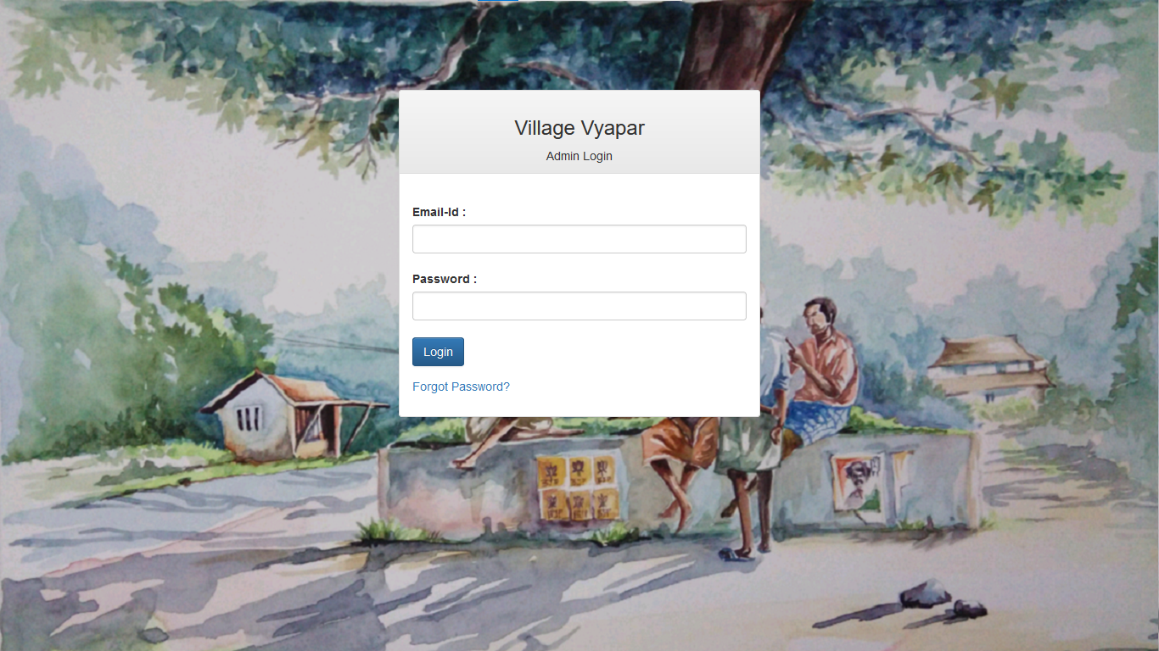

**Validate Credential**

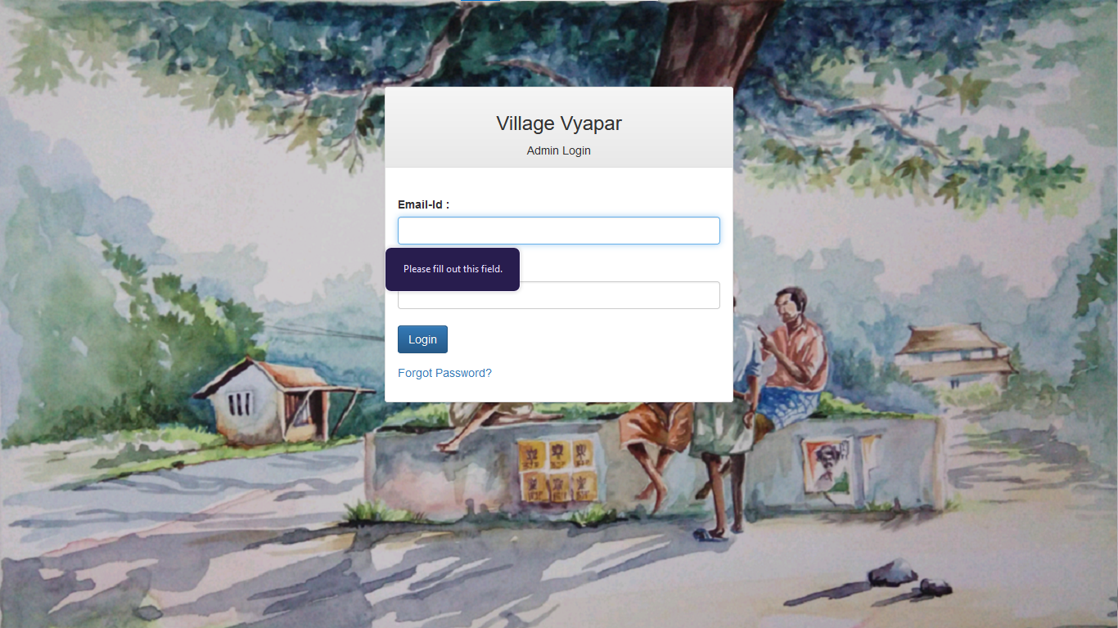

**Invalid Login-credential**

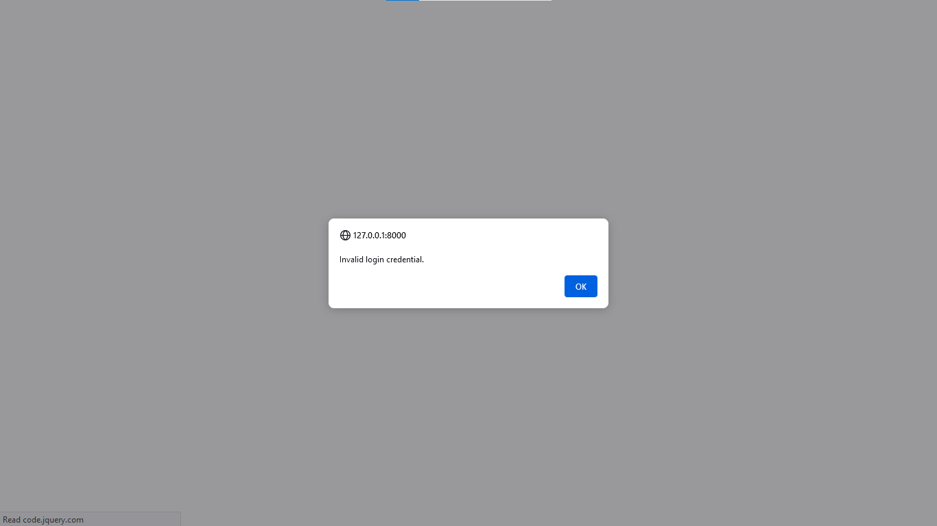

**Admin Dashboard**

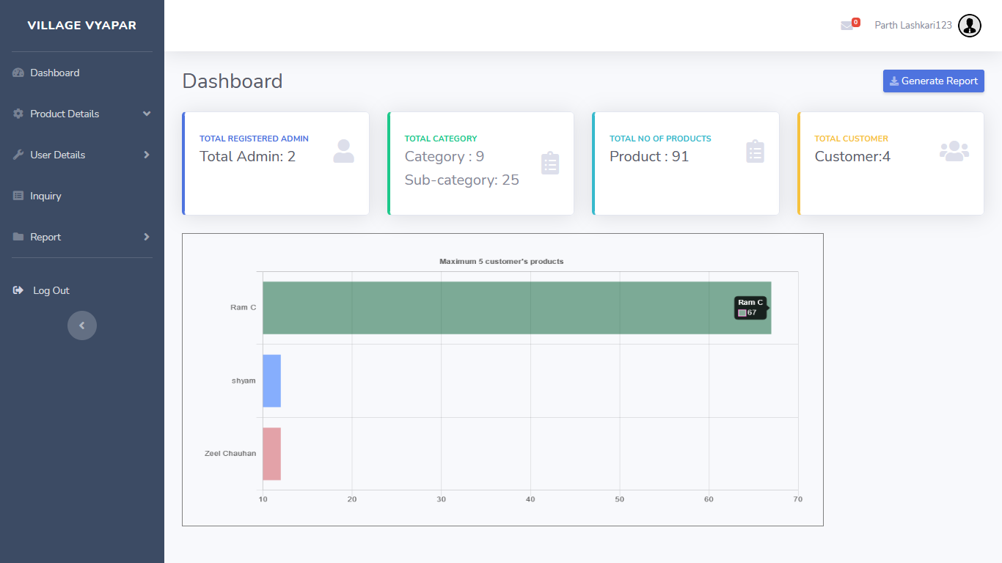

**Show Categories**

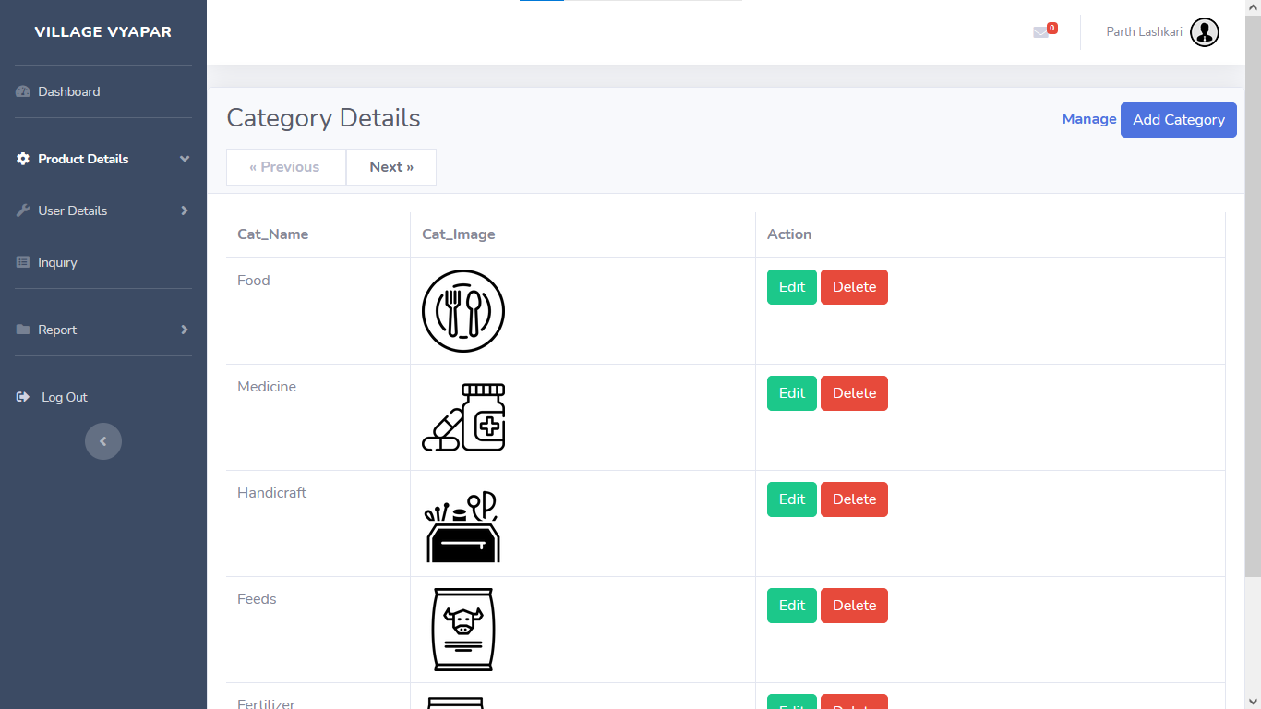

**Add Category**

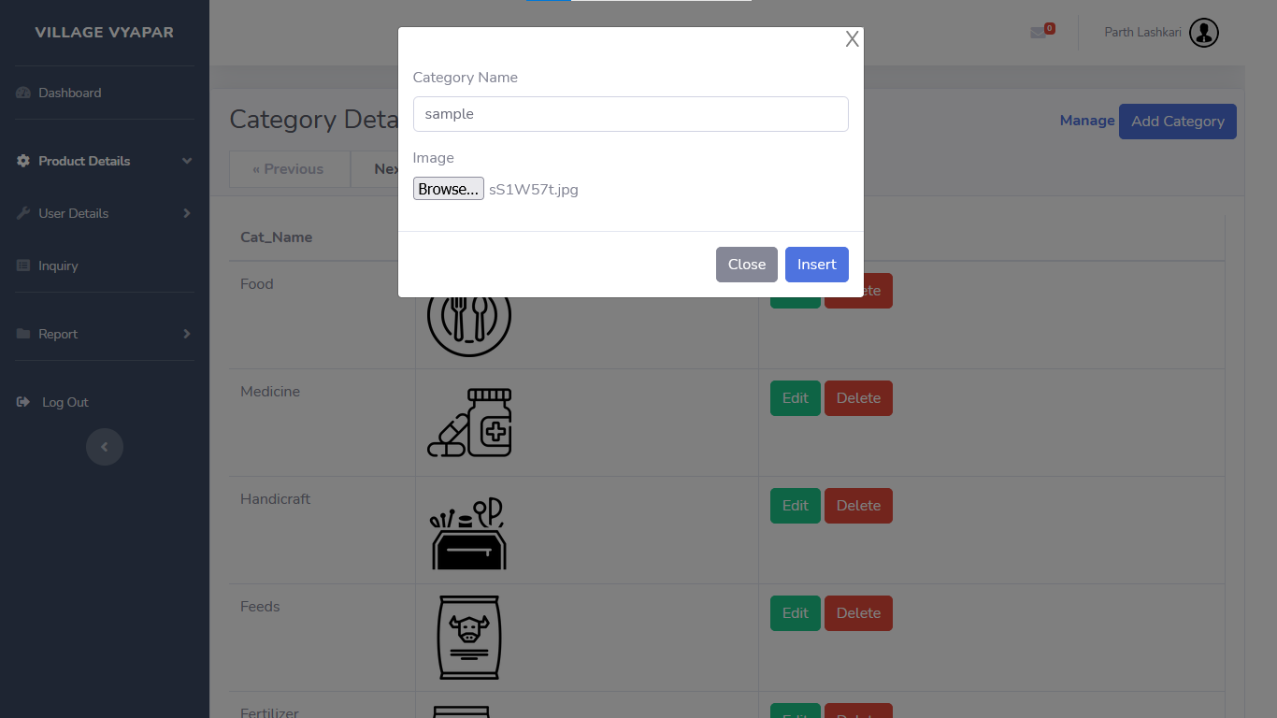

**Added New Category**

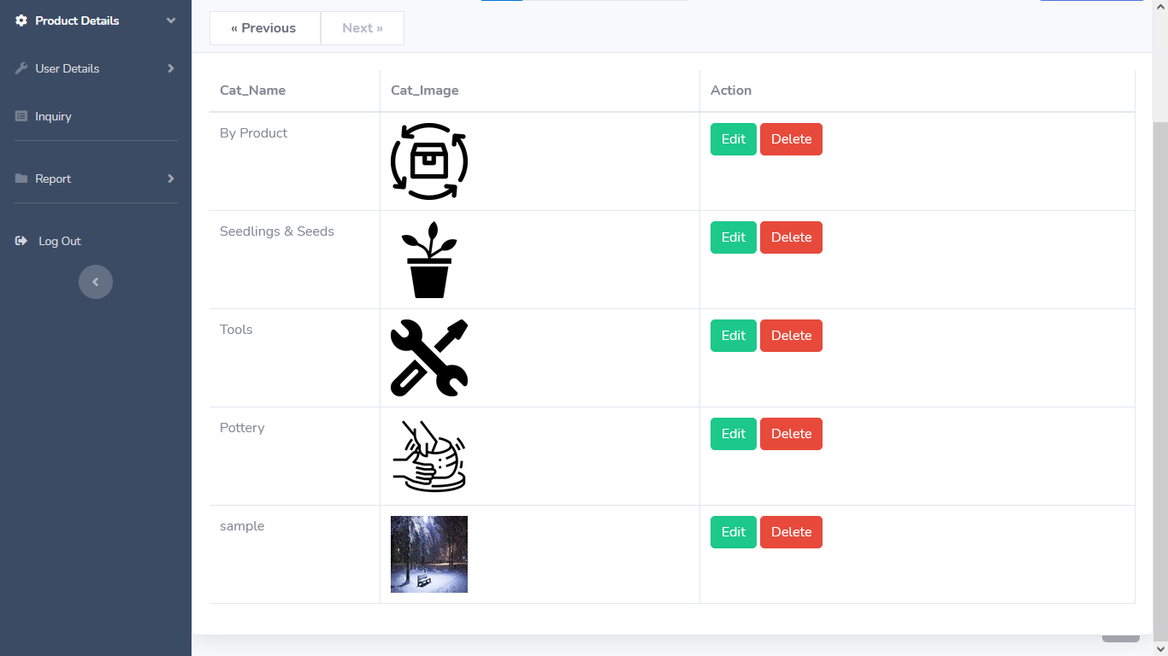

**Edit Category**

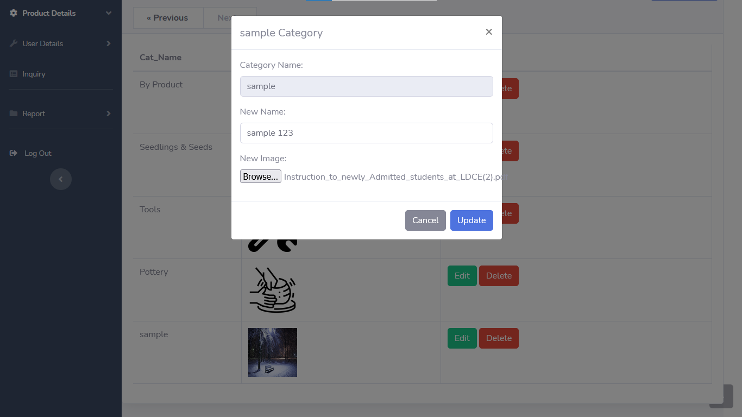

**Edit Category**

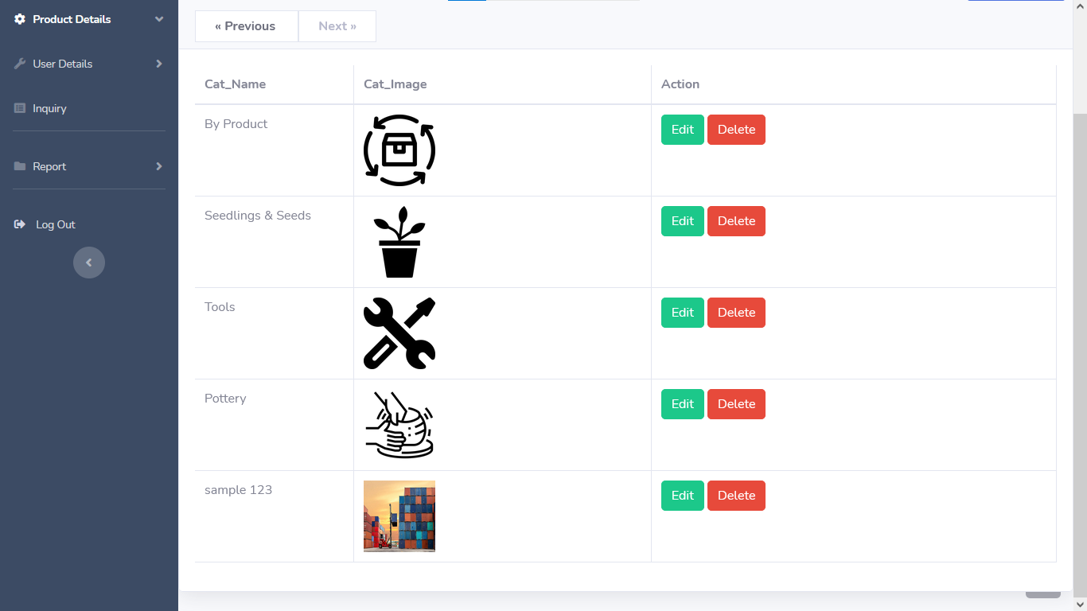

**Delete Category**

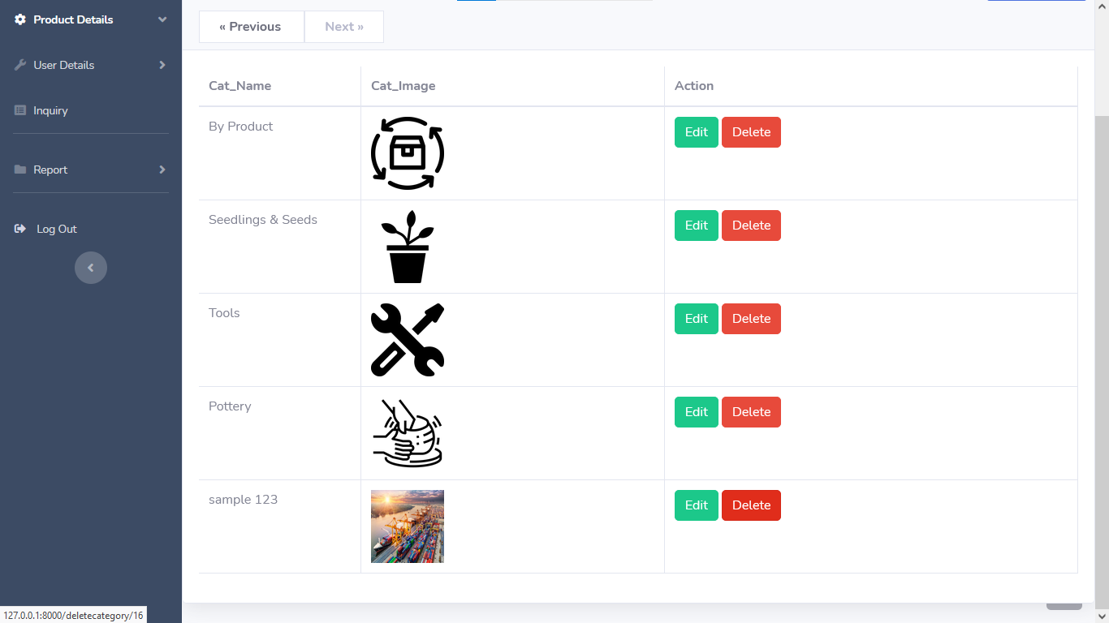

**Delete Sample Category**

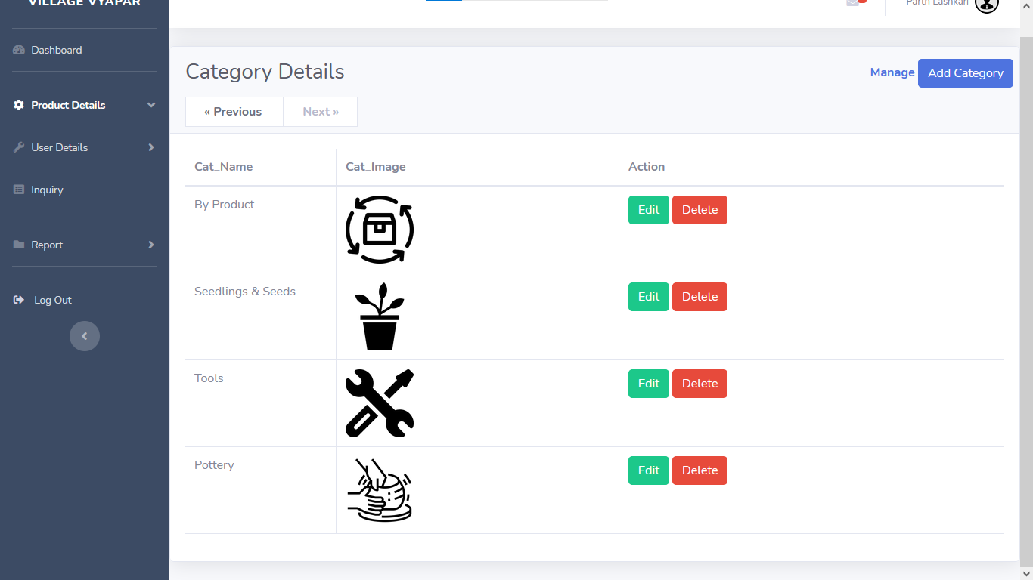

**Show Sub-Category**

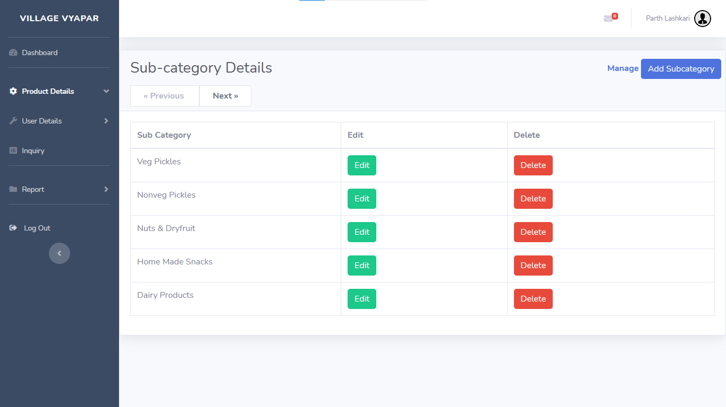

**Add Sub-Category**

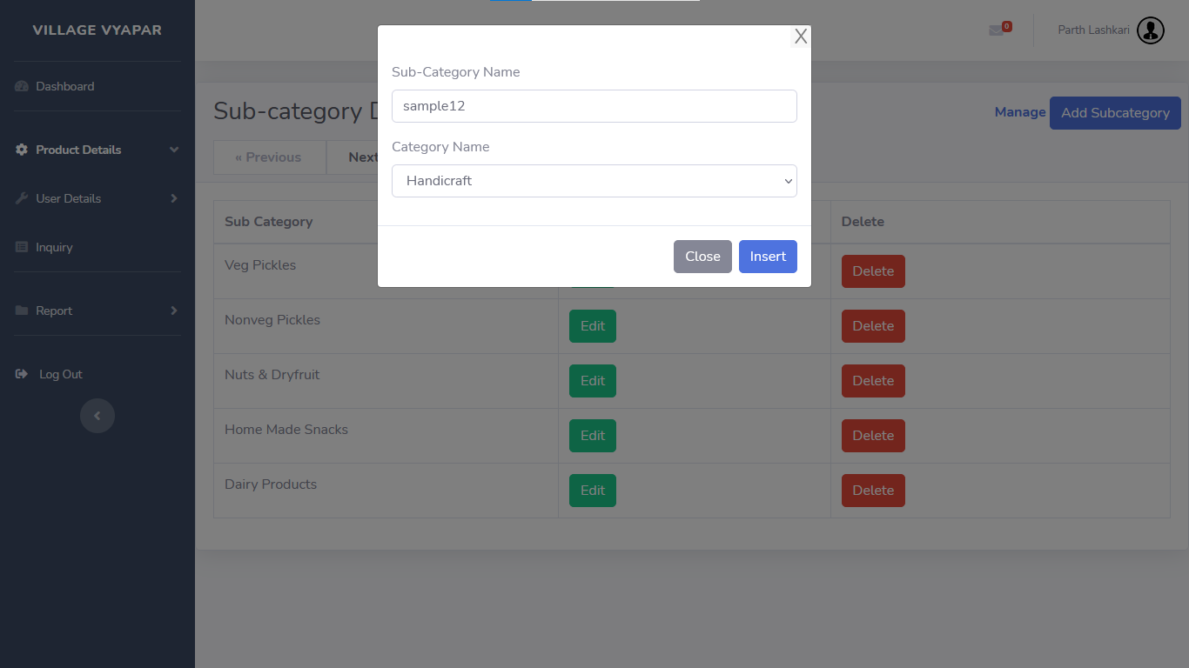

**Added New Sub-Category**

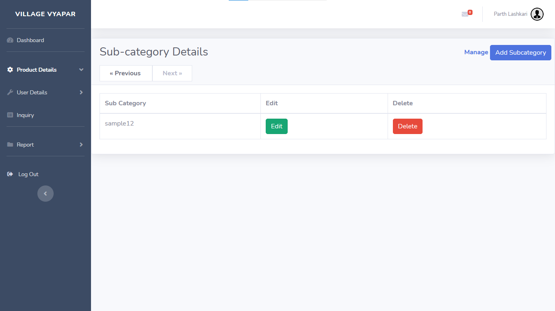

**Delete Sub-Category**

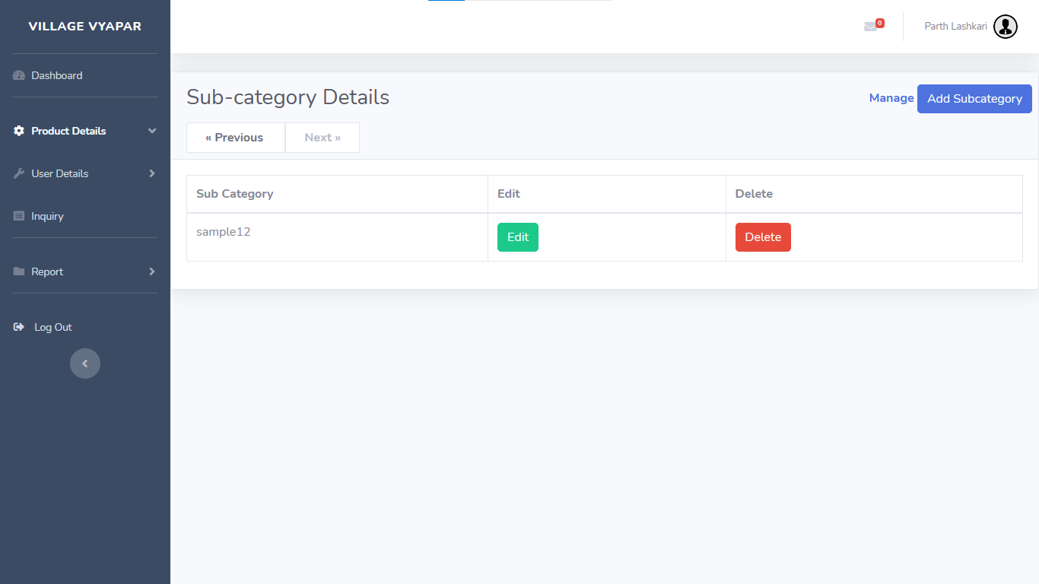

**Deleted Sub-Category**

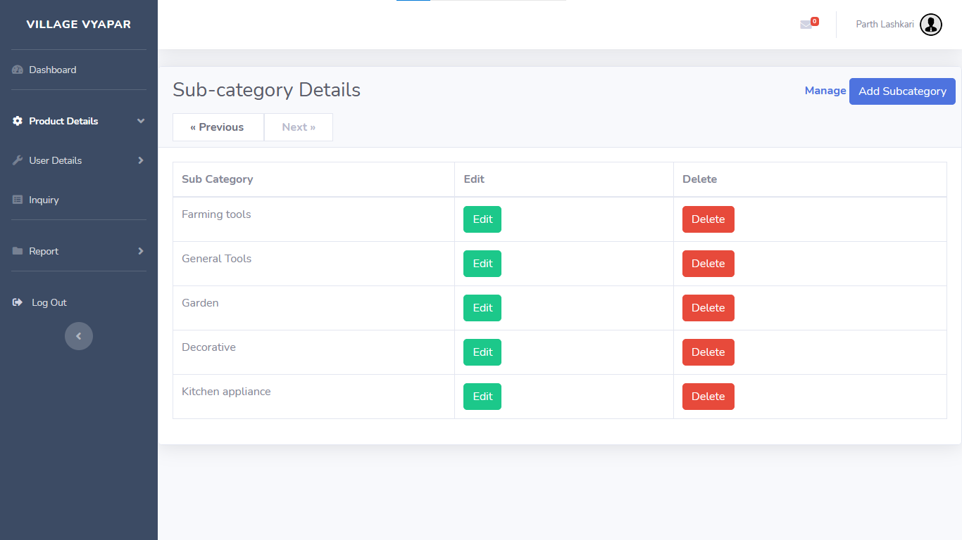

**Shows Products**

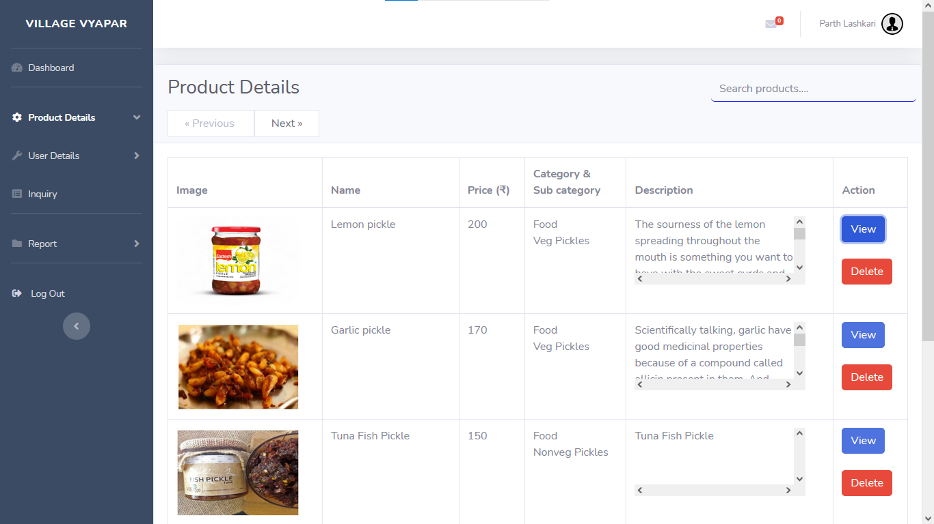

**View Product**

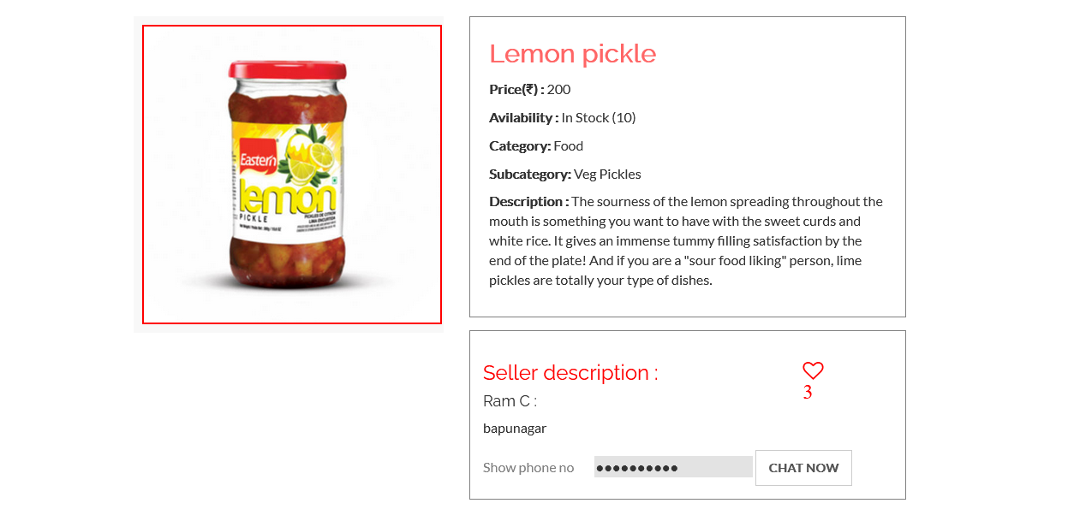

**Delete Sample Product**

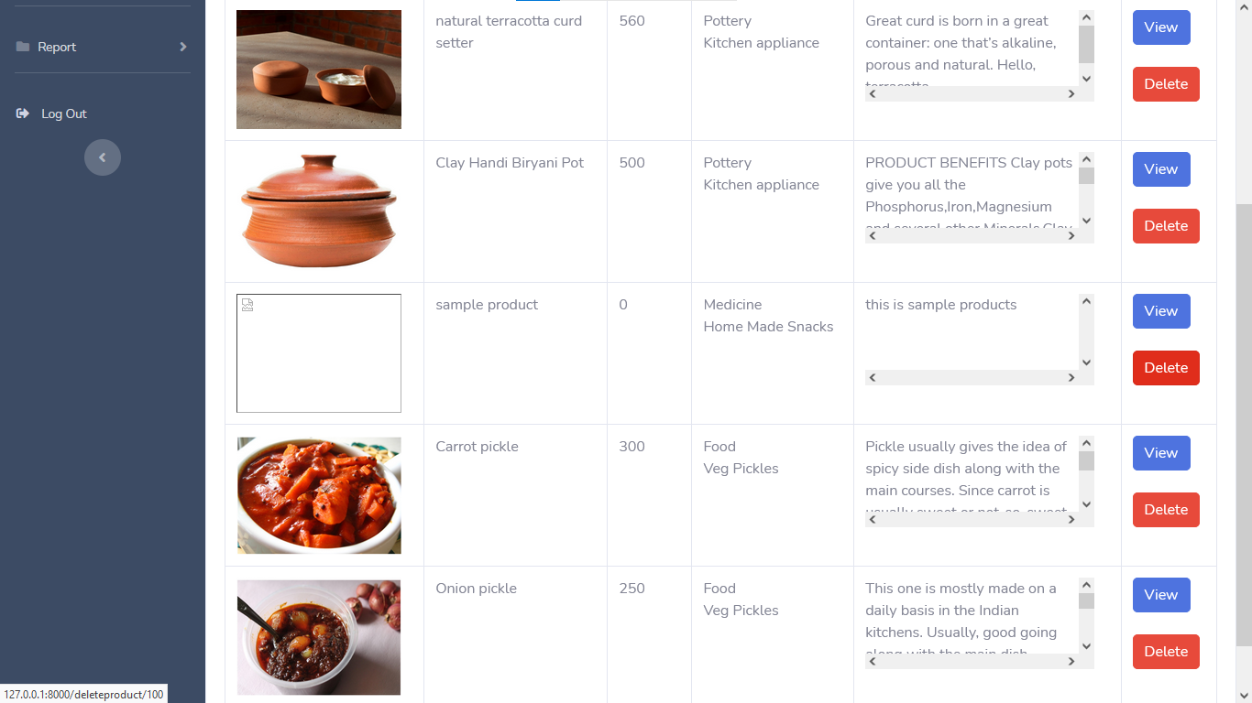

**Deleted Sample Product**

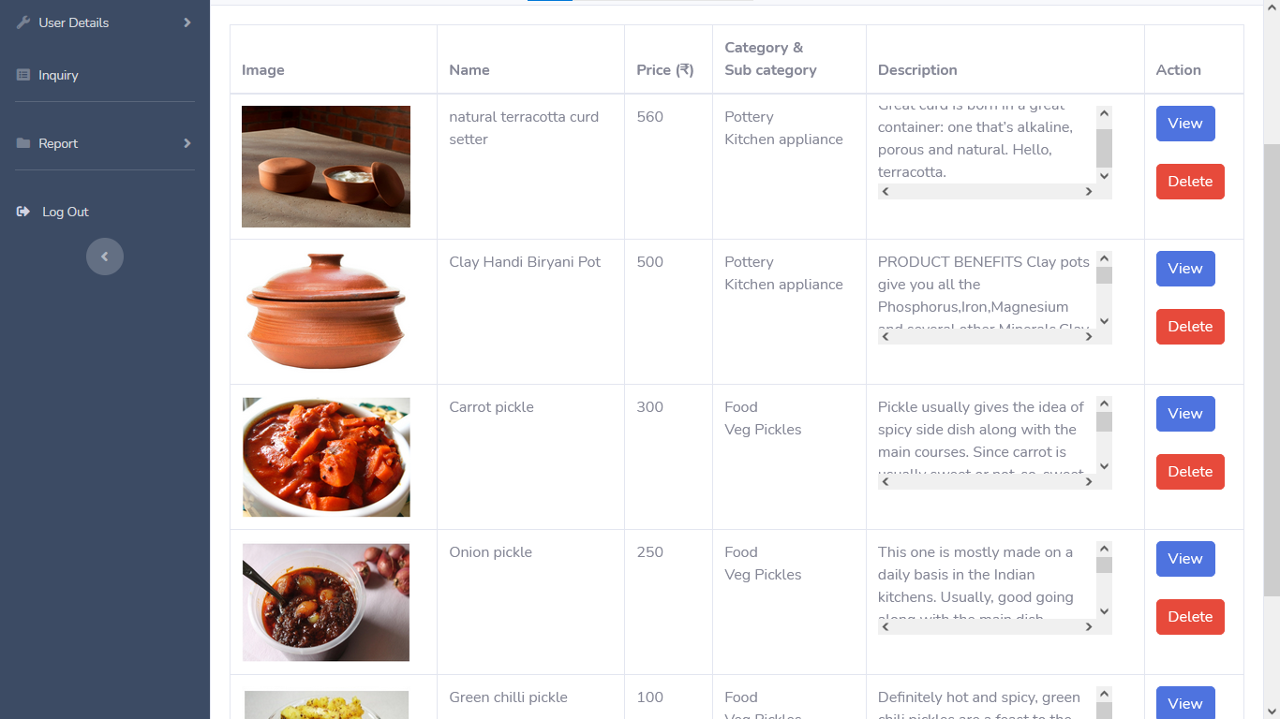

**Search Product**

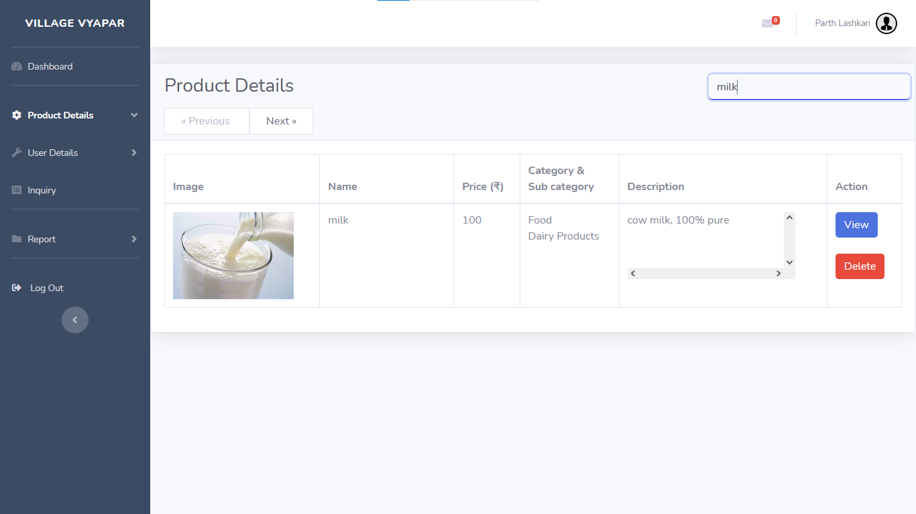

**View customers**

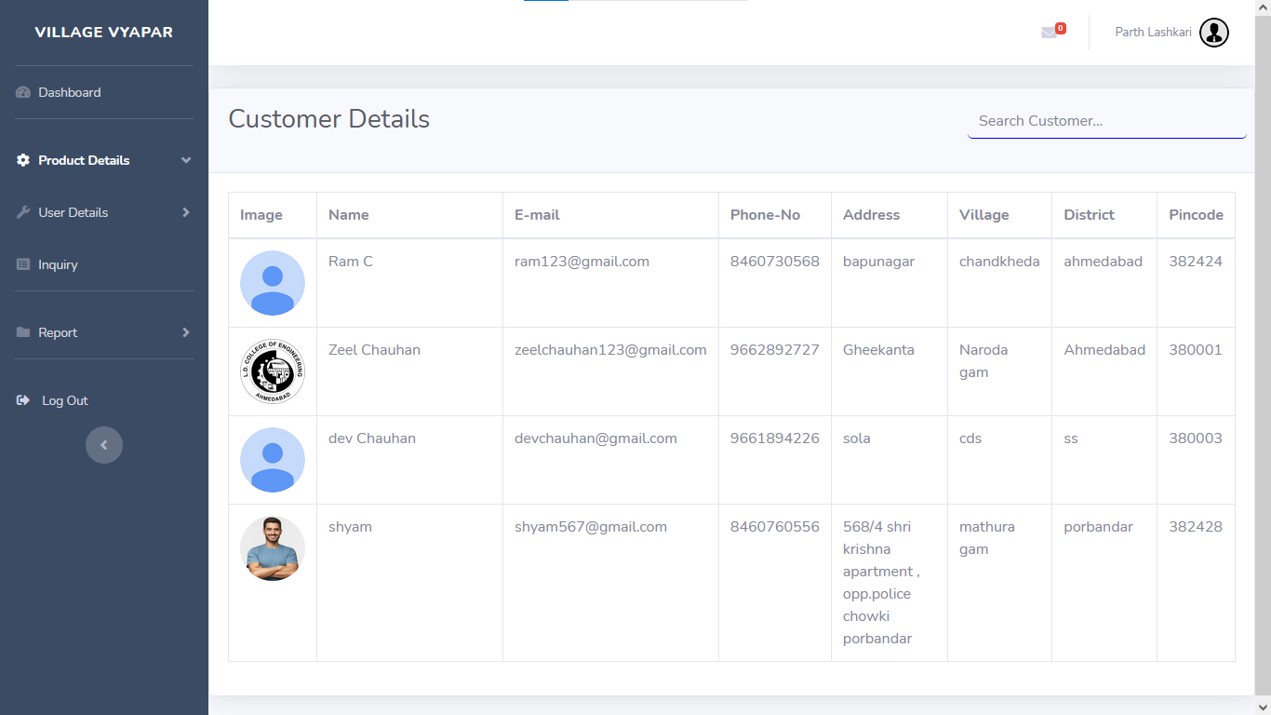

**Search Customer**

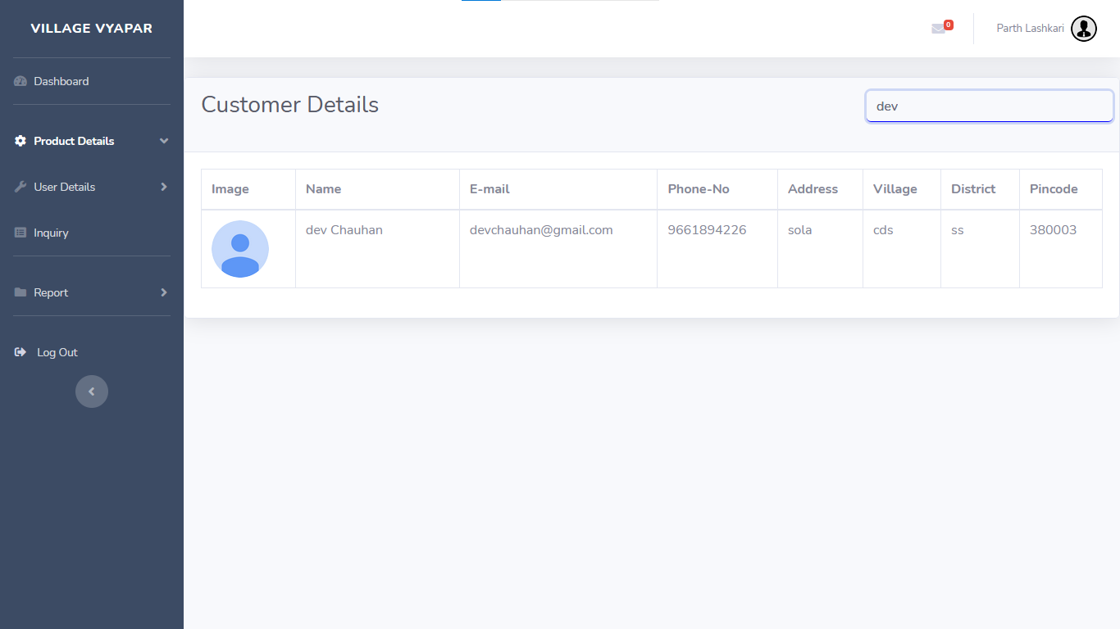

**View Admin list**

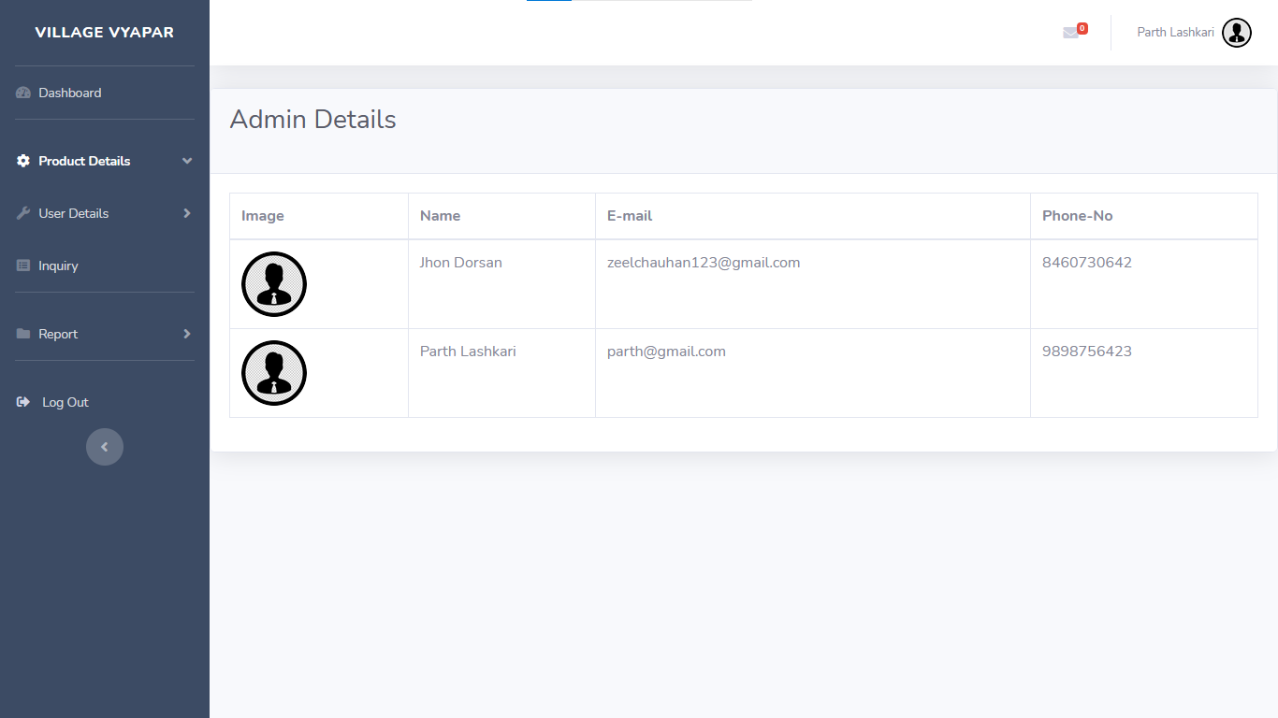

**Show Inquiry**

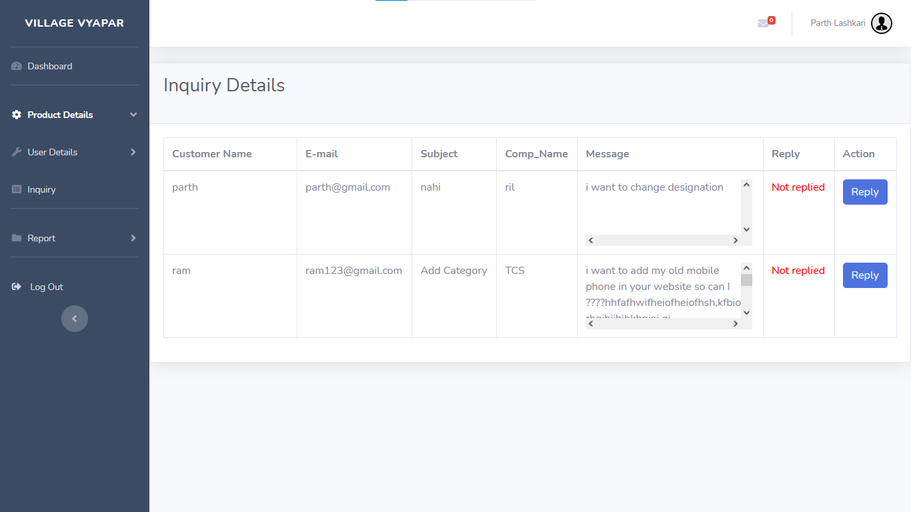

**Reply To An inquiry**

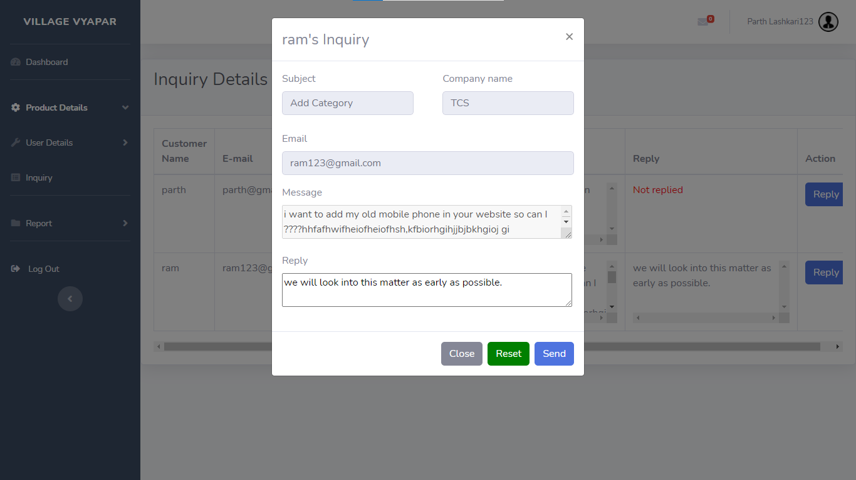

**After Reply To An inquiry**

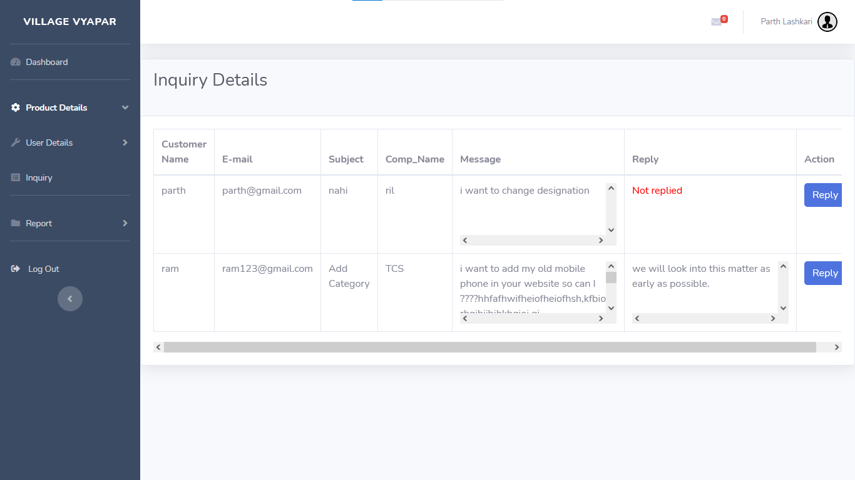

**Show Admin Menu**

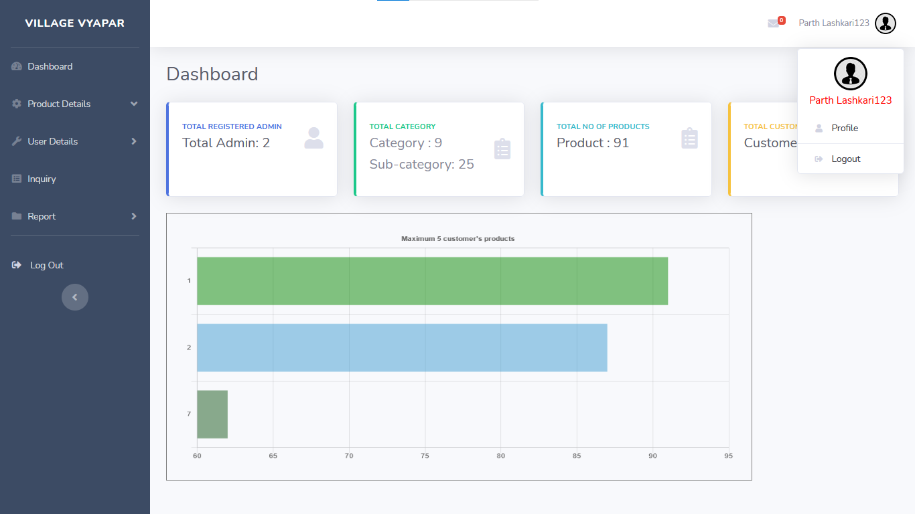

**Edit Admin profile**

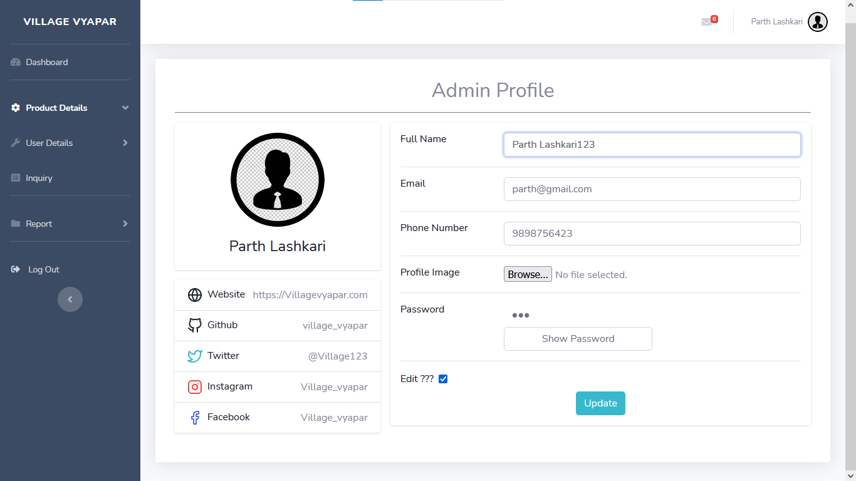

**Edited Admin Profile**

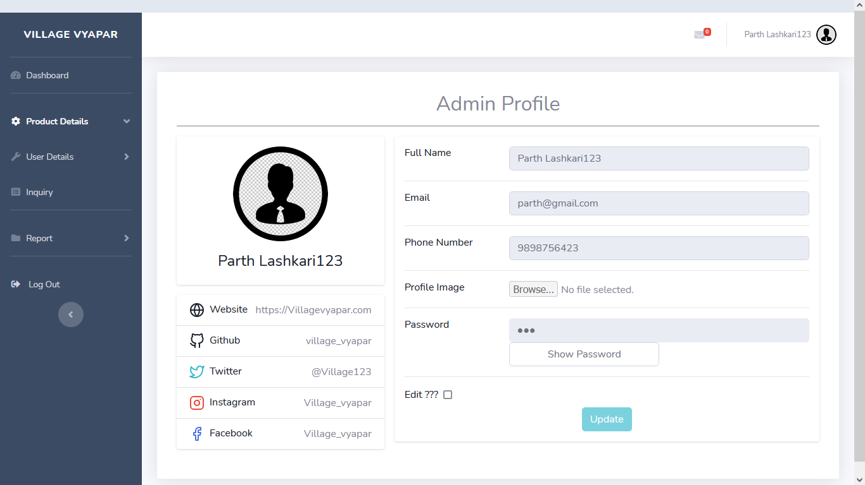

**Admin Forgot Password**

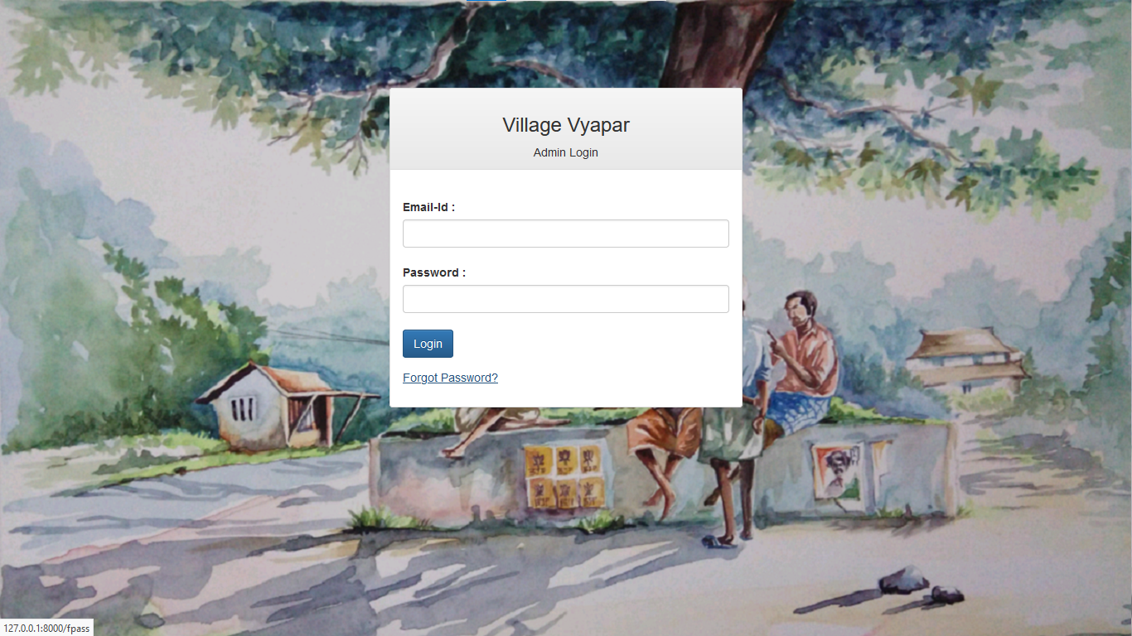

**Admin Forgot Password**

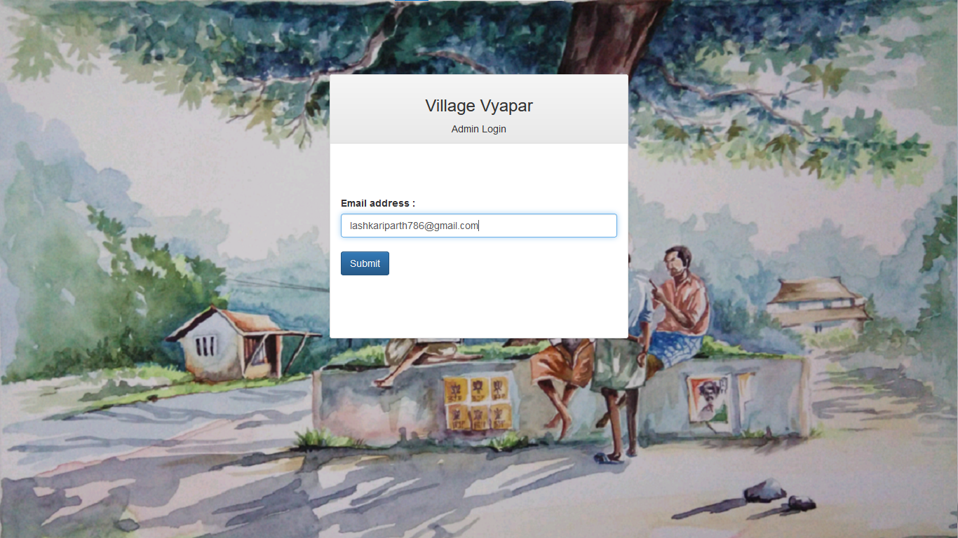

**Security Code on Mail**

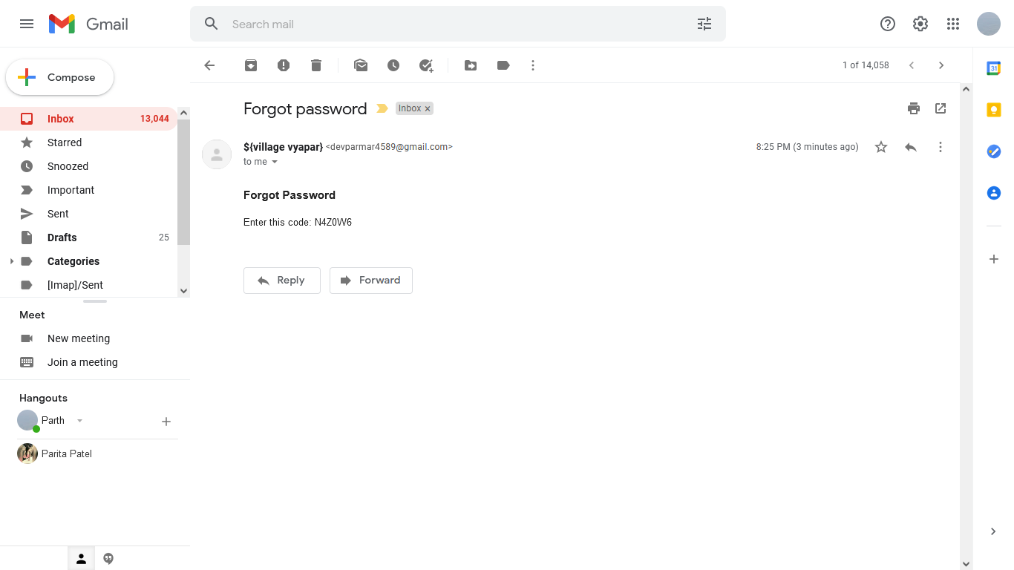

**After entering security code and detail**

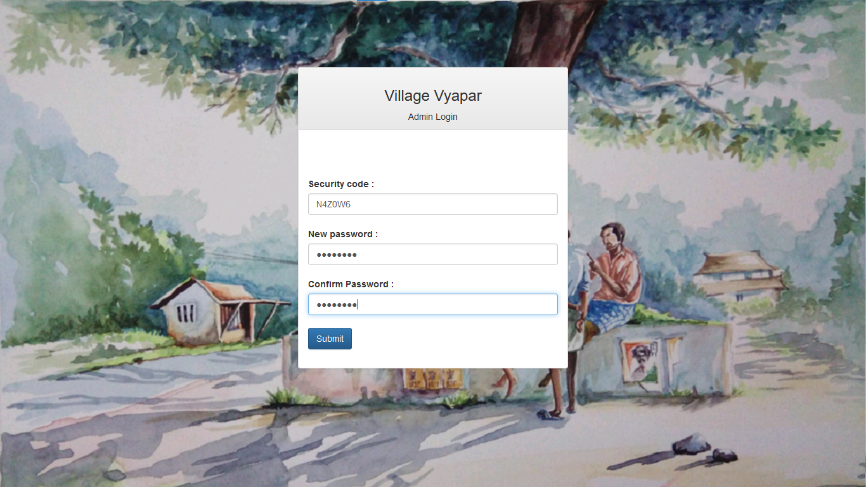

**Admin Logout**

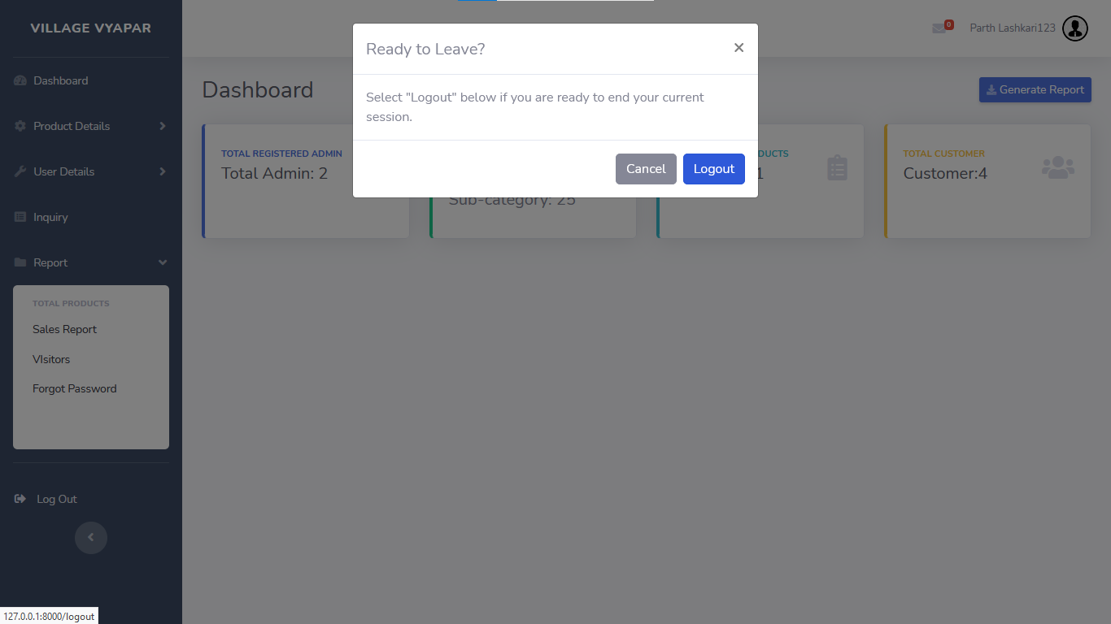

**Bibliography**

Bibliography is nothing but the list of all the sources you have used in the process of researching your work. There are many books and websites that can help us proper guide to implement out system in the right direction.

**Websites:**

* [www.laravel.com/docs/](http://www.laravel.com/docs/)
* [www.mirchi.com](http://www.mirchi.com/)
* [www.bootstrap](http://www.bootstrap/)
* [www.chart.js](http://www.chart.js/)
* [www.stackoverflow.com](http://www.stackoverflow.com/)
* [www.youtube.com](http://www.youtube.com/)